The Genome Islands on the Science Circle Grid
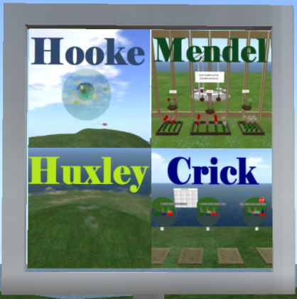
Welcome to Genome on VIBE. Most of the activities you see here were copied over from Genome Island in Second Life. However, in VIBE, they are spread out and occupy three separate islands. Most of the transmission genetics is on Mendel. Most of the molecular genetics and human genetics is on Crick. The cell biology activities are on Hooke. A fourth island, Huxley, which will focus on genetics and diversity, is still undeveloped.
Mendel:
At the entrance to Mendel's Garden Path is an aerial map of the 11 activity areas located along the Garden Path. Click on the sign to get a copy of the map and a notecard listing the activities at each station. Three of the stations are: the Monohybrid Cross, the Cattery and the Mixollama Herd.
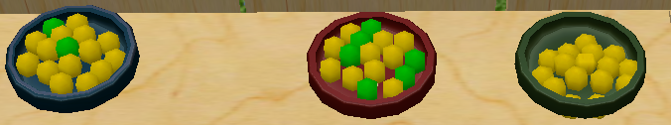
Monohybrid Cross: Three dishes of peas illustrate the principles of inheritance discovered by Mendel by crosses following peas through four generations.
The Mating Game: Three more dishes of peas allow you to test your understanding of Mendel's principles by figuring out the genotypes of six sets of parents.
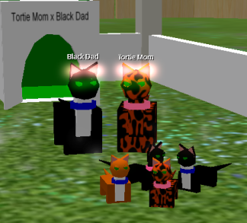
The Cattery: This station illustrates how the inheritance of X linked traits differs from the inheritance of the autosomal traits studied by Mendel. Orange coat color is carried on the X chromosome in cats, and furthermore, in female mammals, only one X chromosome is fully active in any group of cells. This combination of traits leads to unique patterns of coat color inheritance for each possible pair of orange or nonorange parents.
The Mixollama Herd: The Mixollamas are accompanied by an illustration of how independent assortment of alleles occurs during meiosis in individuals with multiple chromosomes. The mixollamas have multiple body parts, each of which can express a different color as a consequence of independent assortment.
Crick:
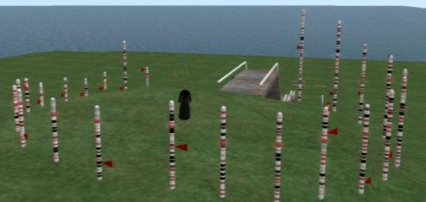
Crick Island is divided into several sectors. Four of these are housed in buildings in different quadrants of the island: Human Genetics, Historical Genetics, Fly Base and the Crick Pavilion. Connecting these structures are Ribosome Row and several Genome Galleries. At the center of Crick Island is Chromosome Hill, which contains scale models of all 24 human chromosomes. Each chromosome gives information about itself and an example of one of its genes.
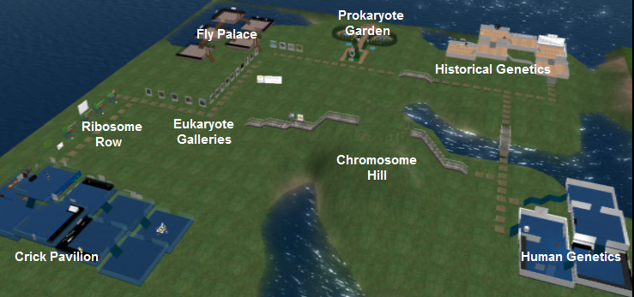
The Crick Pavilion illustrates the experiments that established DNA as an informational molecule, as well as various aspects of DNA structure, genetic coding and protein synthesis. At the entrance of the Crick Pavilion is Ribosome Row, which illustrates details of protein assembly.

Historical Genetics:
The Historical Genetics Center shows how the study of gene sequences and chromosome patterns can help solve historical and evolutionary questions. We will visit the Chromosomal Syntenies activity, which illustrates how blocks of genes have been conserved across species.
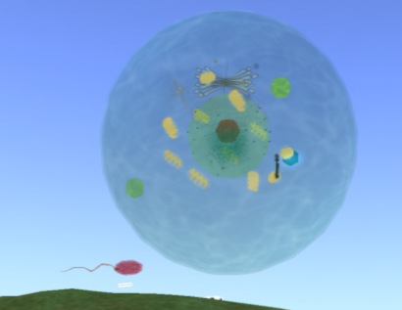
Hooke:
The focal center of Hooke Island is two scale models (more or less) of prokaryotic and eukaryotic cells. You can enter and walk around in the large eukaryotic cell, where both nuclear and cytoplasmic organelles are displayed. Circling the Cell Models is a series of courtyards that display other features of cells.
The Macromolecules Court illustrates the composition of the major classes of macromolecules found in living organisms. Ten more courts invite visitors to learn other aspects of cell biology, like membrane structure and transport, osmosis, differentiated cell types in plants and animals, cell division, photosynthesis and cell respiration.

