**Genome Handout Six: The Birds and Bees**

Developed by Greg Perrier

**Introduction**

This document will inform you how to download the Phoenix Firestorm Viewer (it is free) for Second Life (SL), how to get your own avatar (body) in SL, and how to get to the right location at Genome Island in SL. The last part of this handout provides detailed instructions for completing two different genetic exercises at Genome: the genetics of feather color in Budgie birds (a type of parrot) and exoskeleton color and eye color genetics in bees. This worksheet was initially developed by Glory Ngimaju and Noraybeth Nieto as part of their honors option activities. Two genes control feather color in budgies and one of these genes is sex linked. In bees, the males are haploid and the females are diploid, but only the queen bee lays eggs. These aspects of the bird and bee genetics make the genetics different from what Mendel discovered with the garden peas. This worksheet assumes you have a basic understanding of genetic terms. Once you have installed Phoenix Firestorm on a computer, have an avatar, and have arrived at the Genome Island please feel free to look around and see all the fun biology activities that are there.

**Downloading Second Life**

There are different viewers for SL such as the Second Life webpage viewer (standard viewer), Emerald Viewer, Phoenix Viewer, and Imprudence Viewer. Each viewer has its advantages and disadvantages. The Phoenix Firestorm Viewer (called the Firestorm Viewer) is one of the most stable viewers and is the viewer loaded on the computers at the Manassas Campus. For that reason, the directions for this worksheet assume you are using the Firestorm viewer.

If you have already downloaded the Phoenix Firestorm SL viewer and already have an avatar, log into Firestorm and go to the section below about the Caledon Oxbridge SL Orientation. If you have downloaded Phoenix Firestorm but do not have an avatar, then go to the section below on getting an avatar. If you need to download and install the phoenix firestorm viewer, then go to the following webpage.

<http://www.phoenixviewer.com/downloads.php>

On this webpage, locate the Firestorm Downloads for either Windows or Mac. Select either Windows or Mac (depends on your computer) and download the file to your computer. Then open and run the downloaded file to install the latest version of Phoenix Firestorm. Once you have installed Firestorm, a Firestorm icon should be on your desktop. You will need the IT people to load Phoenix Firestorm on most NOVA campus computers, but it is loaded on the computers in the general student computer labs on the Manassas Campus (MP 120 and MH 211) and might be available on computers on other campuses.

**Getting an Avatar**

Once you have downloaded the Firestorm software to your computer you need to get an avatar. To do so, go to the Second Life homepage.

<http://secondlife.com/>

There you will see a sign that says JOIN NOW. Left click on that. This will take you to a page to select an avatar and open an account. First you will select your initial avatar. Later, you can change this avatar or get a new avatar if you want. You will give Linden Labs (the people who own and run SL) some information about yourself such as your email address and birthdate. You must be at least 16 to legally get an avatar. You will then choose a name for your avatar and a password. You will need these to get into the program. Finally the website will ask you if you want to go into Second Life (SL), say no.

Now you are ready to get into SL using the Firestorm viewer. Click on the Firestorm icon on your desktop and after a few seconds you will see a screen with a black bar along the bottom. There will be a place on the right of the bottom bar to enter you avatar’s name and the password you provided when joining SL. After entering your avatar’s name and password, click on Log In and in about a minute you will find yourself in SL. Often you are initially a cloud, but in a few minutes your should see your avatar. Once in SL, you will find yourself at a welcome center. If you are new to SL, I strongly suggest at this point that you visit the SL orientation at Caledon Oxbridge. If you are familiar with SL, you can skip to the section below on how to get to Genome Island.

**How to get to the Caledon Oxbridge Second Life Orientation**

A location in SL called *Caledon Oxbridge* has a great orientation for people new to Second Life. To go to this island in the Firestorm viewer, left click on the map icon on the bottom toolbar (it looks like a map folded in three sections). You should then see a map of whatever area you are in and a box to the right of map that has a legend and small boxes where you can enter text (see image next page). Delete what text is in the box to the left of the word “Find” and type in “Caledon Oxbridge.” Then left click on “Find” and you should see the name of two sims: Caledon Oxbridge and Caledon Oxbridge Village. Left click on Caledon Oxbridge and at the bottom of the box, select the button labeled “Teleport.” This will take you to Caledon Oxbridge University. At the spot where you land are panels that have basic instructions for Second Life, such as how to move. You will see on the floor red arrows leading down the center of a large hall. Follow the arrows out of the hall, across an open plaza, and into another hall. Following the red arrows takes you through six halls in all, each one explaining some aspect of Second Life. It will take you about an hour to read everything and complete all six halls, but the first two halls are the most important for people new to SL. You will learn how to change your avatar’s appearance and will be offered new clothes. Feel free to make the changes and take the clothes. There are often people around the open plaza who are happy to answer questions. Once you have visited *Caledon Oxbridge*, you can visit *New Resident Island* and go to their free medieval shopping area to get different clothes and avatar shapes and skins. Use the same map icon of the bottom toolbar and the same steps you used to get to *Caledon Oxbridge*.

Caledon Oxbridge Map

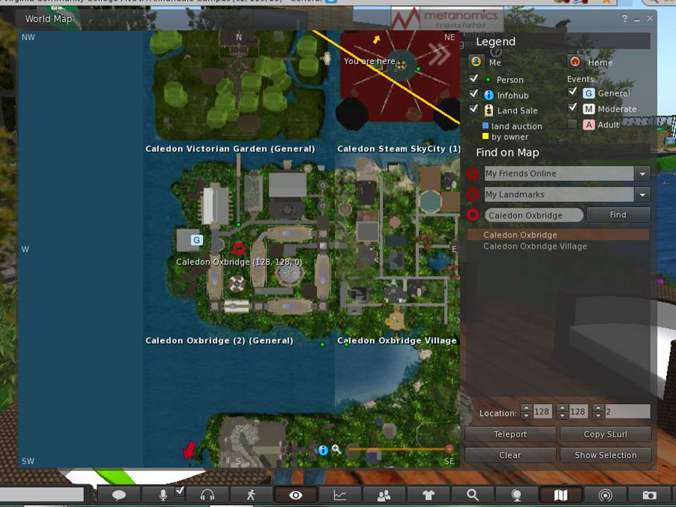

← Caledon Oxbridge

←Teleport

**Getting to the Right Location in SL**

Once you are ready to move on to Genome Island, again left click on the map icon on the bottom toolbar (it looks like a map folded in three sections). You should then see a map of whatever area you are in and a box to the right of map that has a legend and small boxes where you can enter text. Delete what text is in the box to the left of the word “Find” and type in Genome. Then left click on “Genome” in the dropdown box and you will see a map of Genome Island. The red circle is where you will land. Look at the three coordinates at the bottom of the map. They should initially read 128, 128, 0. To land near the Abbey, you should change the coordinates to 158,70, 33 (see image next page). This should have you landing at the right location. Then click on Teleport. You will land to the right of the Abbey. If for some reason you land at the welcome site at Genome Island, you can see the Abbey (a large white building) down the hill. You simply walk or fly to it. Genome Island is run by Texas Wesleyan University and the administrator is Dr. Mary Clark (avatar is Max Chatnoir).

Genome Map

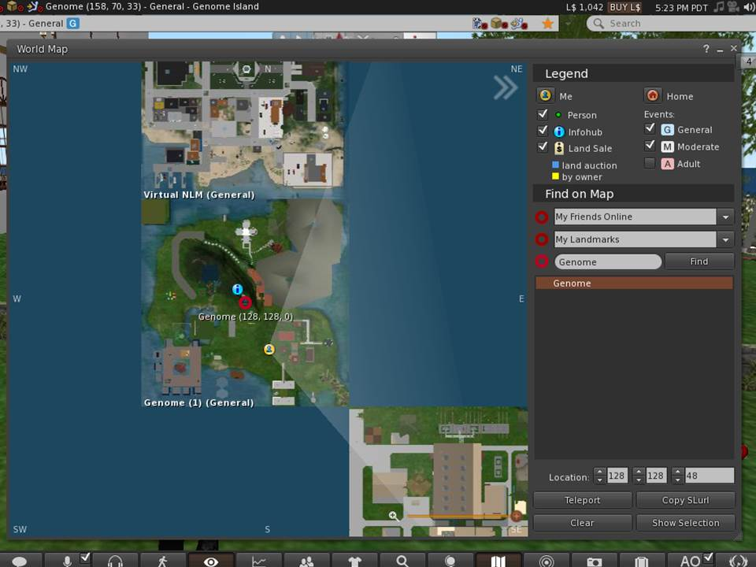

← Genome

← 158, 70, 33

← Teleport

At this point you will need to move around Genome Island in SL. The orientation at Caledon Oxbridge explains how to do this in detail. If you have skipped this orientation, however, here are a few instructions on how to move. To walk simply use the arrow keys on your keyboard. The up key moves you forward, the down key moves you backwards, and the left and right keys turn you. Take 20 seconds and practice moving around. In SL, your avatar can walk, run, and fly. To change from walking to running or flying, left click on the walking person icon on the bottom toolbar. This icon looks a lot like the walk symbol at a crosswalk. A small box appears on your screen with three icons across the bottom - walk, run, and fly - from left to right, respectively. Click on the fly icon and your avatar rises in the air. Use the dashed arrows on the right of the box to move higher and lower. You can use the arrow keys on your keyboard or the arrows in the box on your screen to move your avatar in the fly mode.

Once you are at the Abbey you should create a landmark so you can return here easily. To create a landmark, right click on World on the top toolbar and in the drop down box, select “Landmark this Place.” The next time you want to come to the Abbey at Genome Island, click on your inventory (suitcase icon on the bottom toolbar) and select Landmarks, and click on Genome Island. You will get an option to teleport to Genome Island. This will return you to the Abbey.

Before starting the activity, there are a few setting changes that might improve your experience in SL. If you would like to hear sounds better, left click on the speaker icon located in the top right of your screen just below the red box with the X. Make sure all the sounds options are checked and adjust the volume for each as needed. If you find the SL program is running slowly, stalling, or crashing often you can reduce the graphics quality and speed. To do this, left click on the word Avatar in the top left corner of your screen. In the drop down box select Preferences. Under Preferences, select Graphics. Select General under Graphics and you should see a scale for Quality and Speed Performance. Set this to low. To exit Firestorm click on the red X at the top right of your screen.

.

SL is like a large city. At any time there are about 50,000 people logged in. Most of those people are nice and respectful, but like any city, there are people who might bother you. As long as you stay on the Genome Island, it is unlikely anyone will bother you. If they do, email me their name and simply log out of SL and return later.

**The Activity Starts on the Next Page**

**Genome Six Activity – The Birds and Bees**

Once you are at the Abbey, look off to the left of the Abbey and you should see a view like that shown below. The bee hives you need to work with are located just beyond the steps. The budgie activity is further away, up some stairs. Go first to the budgie area.

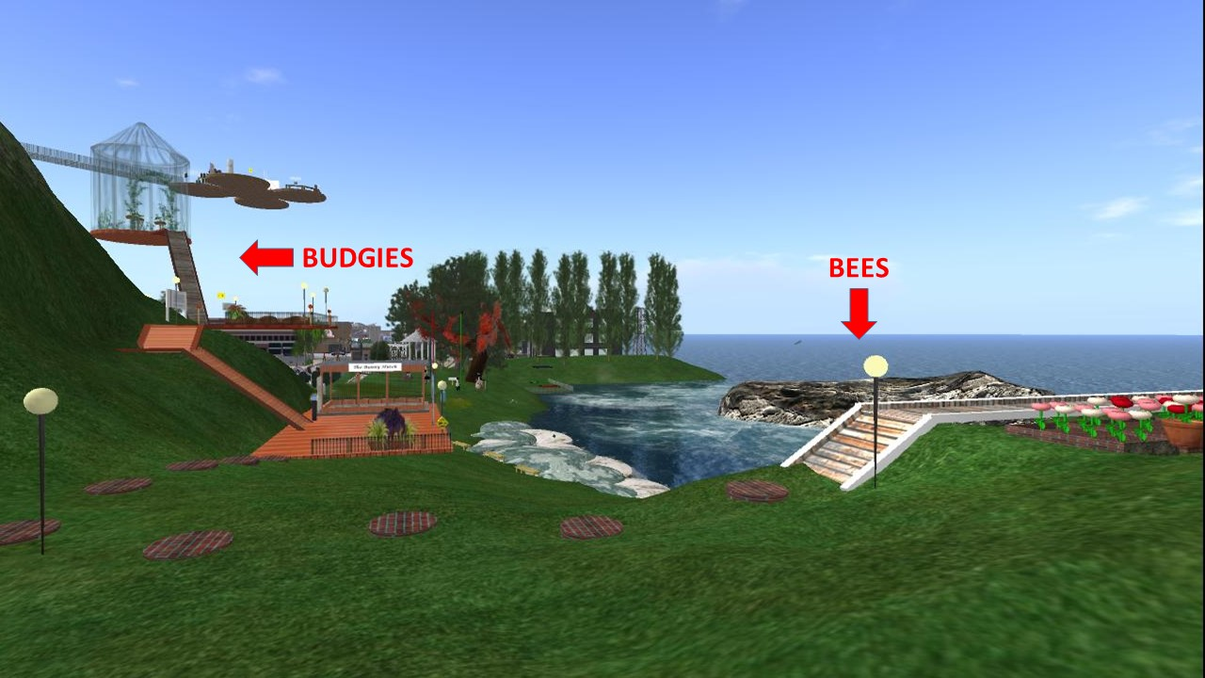

**Budgies**

Climb one set of stairs to a deck and walk past a circling yellow cube with the number 6 on it and you will see a sign that says the “Aviary” (see image next page) Left click on this sign to get offered a notecard about budgie genetics. Accept the notecard and read it.

The notecard explains how feather color in budgies is controlled by two genes. The dominant allele of the first gene (the albinism gene) allows the production of a protein called melanin which gives the budgies a blue color. The recessive albinism gene prohibits the production of the melanin protein. The dominant allele of the second gene produces a protein called psittacin which gives the budgies a yellow color. When both genes have the dominant allele, the budgies are green (blue and yellow combined). The budgies are either blue or yellow when only one of these genes has the dominant allele and the other gene has the recessive allele. The budgies are white when both genes have the recessive allele. Thus the budgies have four possible colors, green, blue, yellow and white.

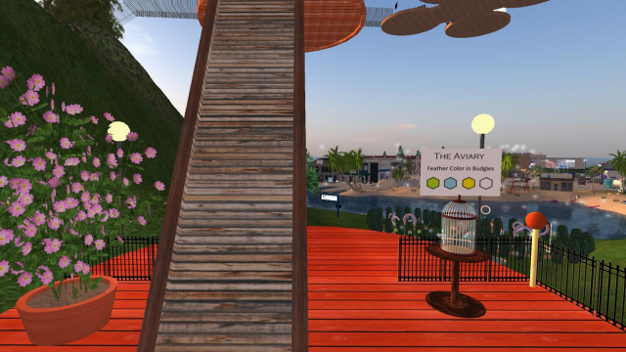

Feather color in budgies is complicated by the fact that the albinism gene is sex linked. In mammals, females have two X chromosomes and males have one X and one Y chromosome. In birds the situation is just reversed, the males have two chromosomes that are the same (Z chromosomes) and females have one Z and one W chromosome. The albinism gene is found on the Z chromosome.

For the albinism gene the dominant allele is shown as Z while the recessive allele is shown as Zi. The gene for psittacin is on an autosomal (non-sex) chromosome and the dominant allele is shown as B and the recessive as b. Now go to the question page at the end of this worksheet and answer question 1.

After answering question 1, climb up the wooden ramp to the aviary at the top (see photo below). Here you will find three pairs of budgies, each pair having one male and one female. Words in white above each bird tell you their color phenotype and gender. Open the chat box by left clicking on the Nearby Chat icon to the far left of the bottom toolbar. Once the chat box is open, left click on one of the bird nests. In the chat box you will see for each egg the color phenotype of the bird that will hatch and the gender. Enter this data in table 1 on the next page. Do the same for the other two nest and enter the data in tables 2 and 3 respectively. You can do the nest in any order.

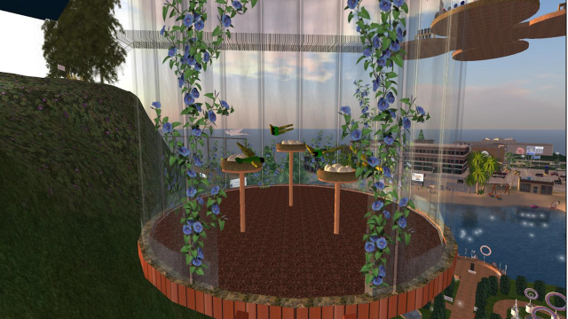

Table 1 Results for the first nest

|  |  |  |
| --- | --- | --- |
| Bird | Gender | Color Phenotype |
| Parent | Male |  |
| Parent | Female |  |
| Chick 1 |  |  |
| Chick 2 |  |  |
| Chick 3 |  |  |
| Chick 4 |  |  |
| Chick 5 |  |  |

Table 2 Results for the second nest

|  |  |  |
| --- | --- | --- |
| Bird | Gender | Color Phenotype |
| Parent | Male |  |
| Parent | Female |  |
| Chick 1 |  |  |
| Chick 2 |  |  |
| Chick 3 |  |  |
| Chick 4 |  |  |
| Chick 5 |  |  |

Table 3 Results for the third nest

|  |  |  |
| --- | --- | --- |
| Bird | Gender | Color Phenotype |
| Parent | Male |  |
| Parent | Female |  |
| Chick 1 |  |  |
| Chick 2 |  |  |
| Chick 3 |  |  |
| Chick 4 |  |  |
| Chick 5 |  |  |

The genetics of color inheritance is complicated by the fact that the albinism gene, which prevents the production of melanin, is sex-linked in budgies, and is carried on the Z gene. In birds, males have two Z genes and females have only one, along with another chromosome called W. Males are ZZ and females are ZW. The gene for albinism is recessive, so an albino male must have two copies of the gene (ZiZi), but an albino female needs only one copy (ZiW).

The dominant gene for psittacin (B) is carried on one of the autosomes. Budgies with the genotypes BB or Bb produce the yellow pigment, while budgies with the genotype bb do not.

Now go to the question page and complete questions 2 through 10. The section on bee genetics starts on the next page.

**Bees**

Locate the three beehives that are near the steps to the left of the abbey (see the photo below). The beehive furthest from the abbey has wild type bees (with dark red eyes and a yellow body). The middle beehive has mutant bees that have two recessive gene phenotypes (white eyes and a dark body). The bees in these two hives mate creating an F1 hybrid generation that show the dominant phenotypes (red eyes and a yellow body). The bees of the F1 generation mate and the offspring form the F2 generation that is found in the beehive closest to the abbey.

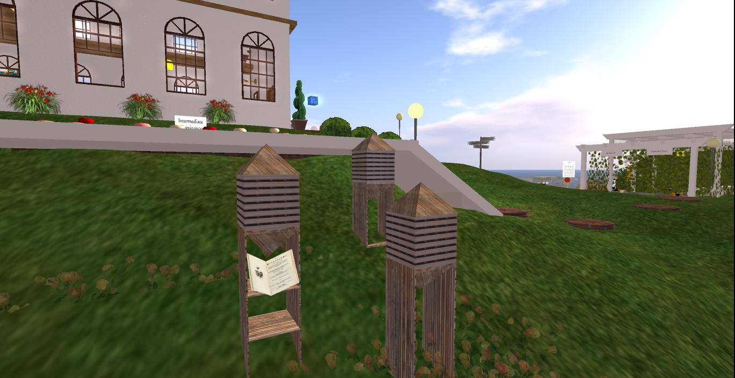

The bee hives have two parts, and pointed top and a cubical body. Clicking on the cubical body starts and stops the bees from coming out of the hive. Click in the wild time cubical part and the mutant cubical part to see what these bees look like. Holding down the ALT key makes your curser into a small magnifying glass. When you click on an object with this curser, you can use your mouse wheel to zoom in or out on an object. Zoom in on the bees and see how they look. Under the cubical part of the hive with mutant bees is an open book. Left click on this book and accept the notecard to read about bee genetics. Left clicking on the pointed top of the hive with the F2 generation gives you another notecard with more information. Open these notecards and read them to get the basics of bee genetics.

In honey bees, the females are diploid (having two of each chromosome) and are the offspring of a male (drone) mating with a female (queen). The male bees are haploid (have only one copy of each chromosome) and come from an unfertilized egg laid by the queen. Because of the males are haploid, genetics in bees is different from what Mendel found in peas.

The two characters of bees for this activity are bee color (with the two phenotypes being yellow or dark) and eye color (with the two phenotypes being red or white). Bees with at least one dominant allele for color (Y) are yellow and bees with only recessive alleles for color (y) are dark. Bees with at least one dominant allele for eye color (R) have red eyes and bees with only recessive alleles for eye color (r) have white eyes. Thus the genotype of wild type bee females is YYRR and for the males is YR. The genotype of the mutant type bee females is yyrr and for the males is yr.

The parent generation cross to produce the F1 generation is shown in the Punnett Square below in Table 4. Note the female is YYRR and the male is yr. Also note the OO row showing that the haploid males are produced without fertilization by sperm. After studying Table 4, go to the question page at the back of the worksheet and answer questions 11 to 16

Table 4

|  |  |
| --- | --- |
|  | Female  Wild  YR |
| Male  Mutant  yr | Female  YyRr |
| OO | Male  YR |

Now you are going to determine the phenotype ratios of the F2 generation by counting the bees of the four phenotypes: yellow – red eye, yellow – white eye, dark – red eye, and dark – white eye. To do this, first click on the cubical part of the F2 beehive, the hive closest to the Abbey. You should see bees coming out soon after you do this. Now you want to get close to these bees. No need to move your avatar, you can hold down the ALT key and click on the ground behind the bees, then you can use your mouse wheel to zoom in on the bees. If you need to center the bees more, you can open the “camera” which allows you to move the view on your screen. This is opened by left clicking on the icon on the bottom toolbar that looks like an eye with a dot (iris) in the middle. Clicking on this icon opens a box with two parts. The arrows on the right allow you to move the view up and down and right and left. The arrows on the left allow you to rotate the view. Zoom in on the F2 bees and center them so the hive just appears on the right of your screen.

The moving bees are very hard to count. So you will take a photo of the bees and count the number of bees with the different phenotypes in the photo (see photo below). To do this click on the icon that looks like a camera on the bottom toolbar. Once you have opened this, one of the options is to email it to someone. Email the photo to yourself by entering your email address in the “To” line. Email four photos to yourself, waiting at least 10 seconds between photos so as not to count the same bee twice. Count the bees by phenotype and enter the results in the table under question 18 in the questions section.

[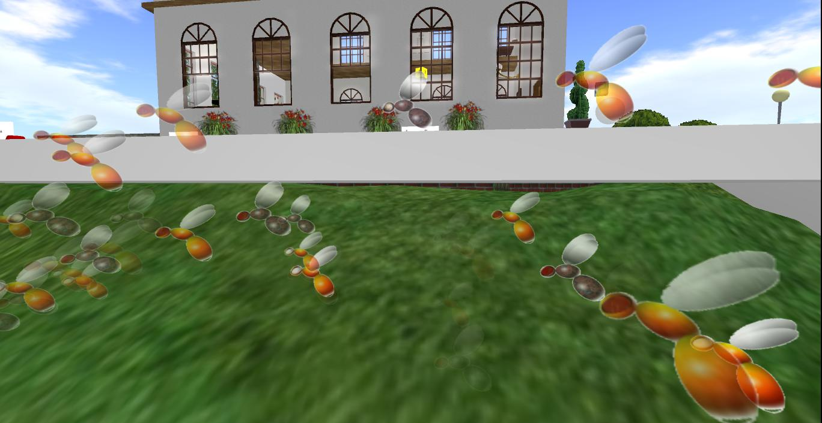](http://slurl.com/secondlife/Genome/174/108/30)

**Questions Section Student Name:**

1. What would be the phenotype for each of the following birds, including their gender?

Color Gender

Bb ZZi: -

bb ZiZi: -

BB ZZ: -

bb ZW: -

Bb ZiW: -

2. Using the phenotypes of the parents and of the progeny given in table 1, determine the genotype of each parent in the first nest.

Male Female

3. Using the phenotypes of the parents and of the progeny given in table 2, determine the genotype of each parent in the second nest.

Male Female

4. Using the phenotypes of the parents and of the progeny given in table 3, determine the genotype of each parent in the third nest.

Male Female

5. Using the genotypes form question 2 create a Punnette Square for the cross shown in the first nest.

|  |  |  |  |
| --- | --- | --- | --- |
|  |  |  |  |
|  |  |  |  |
|  |  |  |  |
|  |  |  |  |

6. Using the genotypes form question 3 create a Punnette Square for the cross shown in the second nest.

|  |  |  |  |
| --- | --- | --- | --- |
|  |  |  |  |
|  |  |  |  |
|  |  |  |  |
|  |  |  |  |

7. Using the genotypes form question 4 create a Punnette Square for the cross shown in the third nest.

|  |  |  |  |
| --- | --- | --- | --- |
|  |  |  |  |
|  |  |  |  |
|  |  |  |  |
|  |  |  |  |

8. If a white female and a white male had offsprings, why must all the offspring be white?

9. Explain how an offspring of a blue male and green female, can turn out white.

10. How does the sex-linked gene affect the offspring phenotype results? Explain

your answer.

**Bee Questions**

11. In bees, the females produce eggs through meiosis. What process do the males use to produce sperm?

12. Contrast the genetypes of the male and female F1 bees.

13. The cross in Table 4 produces all yellow bees with red eyes for the F1 generation. What would be the results if the male was wild type and the female was mutant?

14. Fill in the blank Punnett square for the F1 cross to produce the F2 generation.

|  |  |  |  |  |
| --- | --- | --- | --- | --- |
| Male  Sperm  Genotypes | Female Egg Genotypes | | | |
|  |  |  |  |
|  |  |  |  |  |
| No sperm  OO |  |  |  |  |

15. In the Punnett Square in question 14, what is the body color and eye color for all the females?

16. From the Punnett Square in question 13 determine the percent of bees in the F2 generation with the following phenotypes.

|  |  |  |
| --- | --- | --- |
| Phenotype | Number Calculated | Percent |
| Yellow with red eyes |  |  |
| Yellow with white eyes |  |  |
| Dark with red eyes |  |  |
| Dark with white eyes |  |  |
| Sum |  |  |

17. If the males were not hybrid and this was a normal dihybrid cross, what would the phenotype percent results be?

|  |  |
| --- | --- |
| Phenotype | Percent |
| Yellow with red eyes |  |
| Yellow with white eyes |  |
| Dark with red eyes |  |
| Dark with white eyes |  |

18. Enter the number of bees of each phenotype in each of the four photos and calculate the percent of all bees have each phenotype.

|  |  |  |  |  |  |  |
| --- | --- | --- | --- | --- | --- | --- |
| Phenotype | Photo 1  # | Photo 2  # | Photo 3  # | Photo 4  # | Sum | Percent |
| Yellow with red eyes |  |  |  |  |  |  |
| Yellow with white eyes |  |  |  |  |  |  |
| Dark with red eyes |  |  |  |  |  |  |
| Dark with white eyes |  |  |  |  |  |  |
| Sum |  |  |  |  |  |  |

19. Enter the percent of bees with each phenotype calculated from the Punnett Square (question 16) with the percent counted from the photos (from question 18).

|  |  |  |
| --- | --- | --- |
| Phenotype | Percent from  Punnett Square | Percent from  Photos |
| Yellow with red eyes |  |  |
| Yellow with white eyes |  |  |
| Dark with red eyes |  |  |
| Dark with white eyes |  |  |

20. Should the percent data developed by these two different methods be similar? Explain your answer.