**How Complete the Cat Genetics Activity in Second Life**

Developed by Dr. Perrier

**Introduction**

This document will inform you how to download the Phoenix Firestorm Viewer for Second Life (SL), how to get your own avatar (body) in SL, and how to get to the Cattery Area at Genome Island in SL. Once at the Cattery on Genome Island you will explore the genetics behind the different coat patterns on house cats.

**Downloading Second Life**

There are different viewers for SL such as the Second Life webpage viewer (standard viewer), Emerald Viewer, Phoenix Viewer, and Imprudence Viewer. Each viewer has its advantages and disadvantages. The Phoenix Firestorm Viewer (called the Firestorm Viewer) is one of the most stable viewers and is the viewer loaded on the computers at the Manassas Campus. For that reason, the directions for this worksheet assume you are using the Firestorm viewer. You will need the IT people to load Phoenix Firestorm on most NOVA campus computers, but it is loaded on the computers in the general student computer labs on the Manassas Campus (MP 120 and MH 211) and might be available on computers on other campuses.

If you have already downloaded the Phoenix Firestorm SL viewer and already have an avatar, log into Firestorm and go to the section below about the Caledon Oxbridge SL Orientation. If you have downloaded Phoenix Firestorm but do not have an avatar, then go to the section below on getting an avatar. If you need to download and install the phoenix firestorm viewer, then go to the following webpage.

<http://www.phoenixviewer.com/downloads.php>

On the webpage, find the Firestorm Downloads for either Windows or Mac. Select either Windows or Mac (depends on your computer) and download the file to your computer. Then open the downloaded file to install the latest version of Phoenix Firestorm. Once you have installed Firestorm, a Firestorm icon should be on your desktop.

**Getting an Avatar**

Once you have downloaded the Firestorm software to your computer you need to get an avatar. To do so, go to the Second Life homepage.

http://secondlife.com/

There you will see a sign that says JOIN NOW. Left click on that. This will take you to a page to create an avatar and open an account. First you will select your initial avatar. Later, you can change this avatar or get a new avatar if you want. You will give Linden Labs (the people who own and run SL) some information about yourself such as your email address and birthdate. You must be at least 16 years old. You will then choose a username for your avatar and a password. You will need the username and password to log onto the Firestorm program. Finally the website will ask you if you want to open Second Life (SL), say no.

Now you are ready to get into SL using the Firestorm viewer. Click on the Firestorm icon on your desktop and after a few seconds you will see a screen with a black bar along the bottom. There will be a place on the right of the bottom bar to enter you avatar’s username and the password you provided when joining SL. After entering your avatar’s name and password, click on “Log In” and in about a minute you will find yourself in SL. Often you are initially a red cloud, but in a few minutes your should see your avatar. Once in SL, you will find yourself at a welcome center. If you are new to SL, I strongly suggest at this point that you visit the SL orientation at Caledon Oxbridge. If you are familiar with SL, you can skip to the section below on how to get to NOVA’s campus.

**How to get to the Caledon Oxbridge Second Life Orientation**

A location called *Caledon Oxbridge* has a great orientation for people new to Second Life. To go to this island in the Firestorm viewer, left click on the map icon on the bottom toolbar (it looks like a map folded in three sections). You should then see a map of whatever area you are in and a box to the right of map that has a legend and small boxes where you can enter text. Delete what text is in the box to the left of the word “Find” and type in “Caledon Oxbridge” (see image below). Then left click on

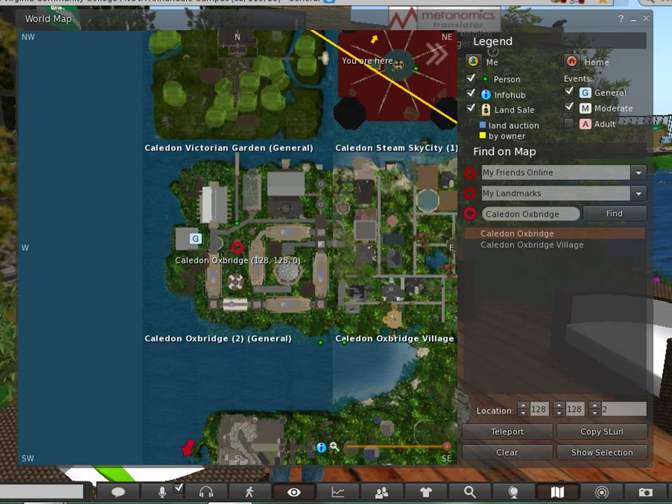

← Caledon Oxbridge

← Teleport

“Find” and you should see the name of two sims: Caledon Oxbridge and Caledon Oxbridge Village. Left click on Caledon Oxbridge and at the bottom of the box, select the button labeled “Teleport.” This will take you to Caledon Oxbridge University. At the spot where you land are panels that have basic instructions for Second Life, such as how to move. You will see on the floor red arrows leading down the center of a large hall. Follow the arrows out of the hall, across an open plaza, and into another hall. Following the red arrows takes you through six halls in all, each one explaining some aspect of Second Life. It will take you about an hour to read everything and complete all six halls, but the first two halls are the most important for people new to SL. You will learn how to change your avatar’s appearance and will be offered new clothes. Feel free to make the changes and take the clothes. There are often people around the open plaza who are happy to answer questions. Once you have visited *Caledon Oxbridge*, you can visit *New Resident Island* and go to their free medieval shopping area to get different clothes and avatar shapes and skins. Use the map icon and the same steps you used to get to *Caledon Oxbridge*.

**Getting to the Right Location on Genome Island**

Once you are ready to move on to Genome Island, left click on the map icon on the bottom toolbar (it looks like a map folded in three sections). You should then see a map of whatever area you are in and a box to the right of map that has a legend and small boxes where you can enter text. Delete what text is in the box to the left of the word “Find” and type in Genome. Near the bottom of the box there are three coordinate numbers next to the word “Location.” These initially read 128, 128, 48. To ensure that you land at the Cattery on Genome Island you need to change the coordinate settings to 132, 90, 28. Then click on “Teleport.” You will be taken to the Cattery at Genome Island (see image below). Genome Island is run by Texas Wesleyan University and the administrator is Dr. Mary Clark (avatar is Max Chatnoire).

[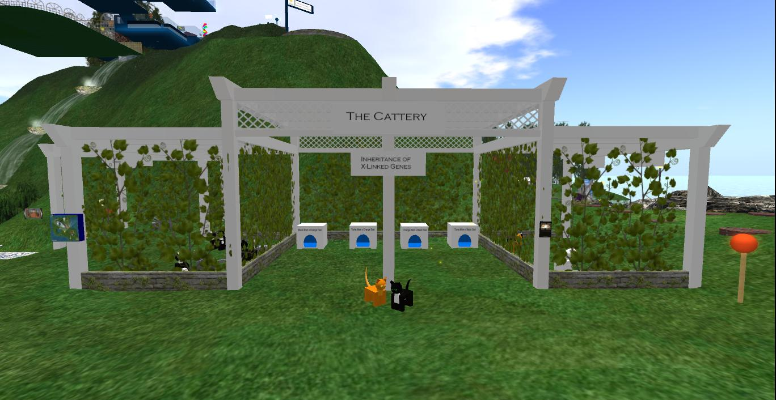](http://slurl.com/secondlife/Genome/135/86/31)

At this point you will need to move around Genome Island in SL. The orientation at Caledon Oxbridge explains how to do this in detail. If you have skipped this orientation, however, here are a few instructions on how to move. To walk simply use the arrow keys on your keyboard. The up key moves you forward, the down key moves you backwards, and the left and right keys turn you. Take 20 seconds and practice moving around. In SL, your avatar can walk, run, and fly. To change from walking to running or flying, left click on the walking person icon on the bottom toolbar. This icon looks a lot like the walk symbol at a crosswalk. A small box appears on your screen with three icons across the bottom, walk, run, and fly from left to right, respectively. Click on the fly icon and your avatar rises in the air. Use the dashed arrows on the right of the box to move higher and lower. You can use the arrow keys on your keyboard or the arrows in the box on your screen to move your avatar in the fly mode.

There are a few setting changes that might improve your experience in SL. If you would like to hear sounds better, left click on the speaker icon located in the top right of your screen just below the red box with the X. Make sure all the sounds options are checked and adjust the volume for each as needed. If you find the SL program is running slowly, stalling, or crashing often you can reduce the graphics quality and speed. To do this, left click on the word Avatar in the top left corner of your screen. In the drop down box select Preferences. Under Preferences, select Graphics. Select General under Graphics and you should see a scale for Quality and Speed Performance. Set this midway between low and mid.

**Activity**

In this activity you will explore the genetics behind cat coat color. This part of the worksheet was initially developed in fall semester 2014 by Grace Burkhardt and Amanda Touma as part of their honors activities in Biology 102. The Cattery is divided into five parts. Starting from the left side (around the left corner) and proceeding around the right corner these are: Stripes, A cat of a different color, Inheritance of X-linked genes, Whiteout, and A deadly tale. Take a minute to find each of these parts to this activity. The directions for each part are provided below.

Stripes

Make your way to the farthest stall to the left of The Cattery with the sign on top reading “Stripes” (see image below). In this area you will see two striped cats: the dad and mom. Left click on the sign “Stripes” above the stall and left click on the option to accept and to keep the notecard. Read the notecard that appears. Once you’ve read the text about the stripped cats, left click on the mother cat and observe the offspring as they appear.

[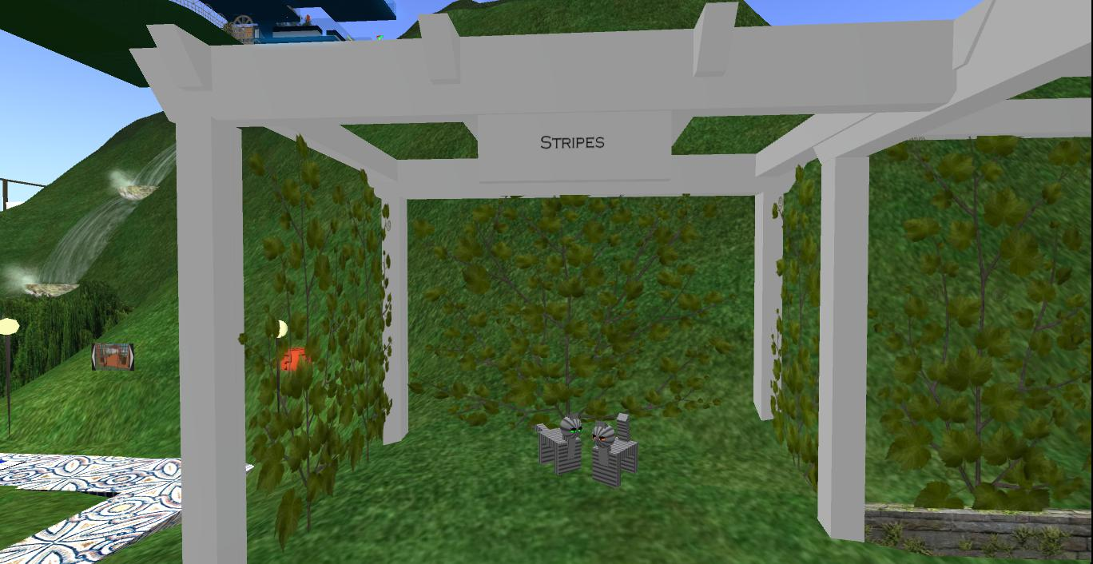](http://slurl.com/secondlife/Genome/124/98/30)

To observe the kittens better, hold down the ALT key and move your curse over the kittens. Open the camera control (eye icon bottom toolbar) to change the view on the screen. Now left click your mouse on a kitten. You can use the wheel on your mouse to zoom in on the kittens. Go to the question pages at the end of this handout and answer questions 1, 2, and 3.

A Cat of a Different Color

Just to the right of the Stripes stall is the stall for “A Cat of a Different Color” (see image below). Inside this tall are three pairs of cats, each pair having a mom and dad cat. Left click on the sign above the stall reading “A Cat of a Different Color” and again left click on accept to access the notecard. You do not need to open the webpage, so click on cancel when offered that. Once you’ve read the text on this card, observe the three

[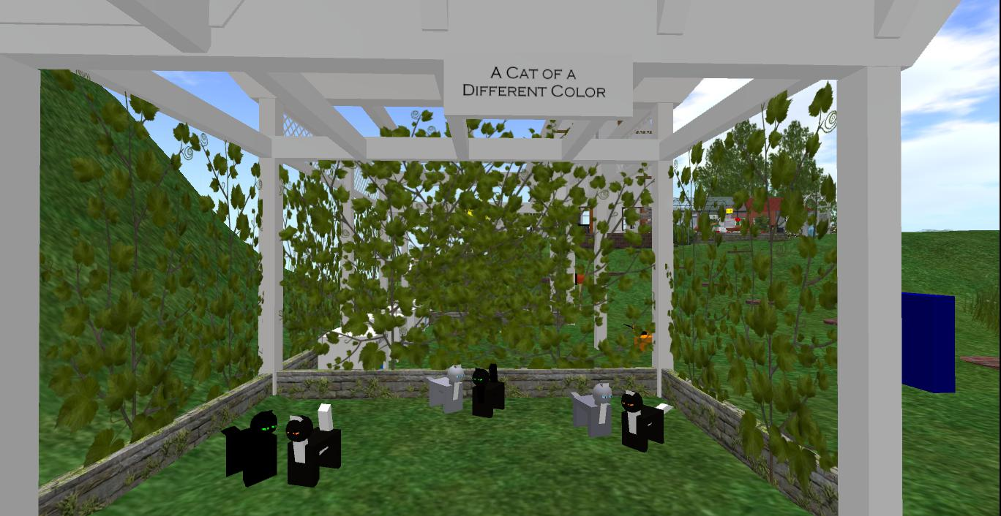](http://slurl.com/secondlife/Genome/123/99/30)

pairs of cat parents. Note that the pair on the left are both black while the other two pairs have one black (mom) and one gray (dad) parent. On the left of the bottom toolbar on your screen you will see “Nearby Chat.” Left click on that and you will get a chat box. Now left click on the black cat mother in the center and observe the offspring as they appear. The results of the cross of the center mom and dad cat will appear in the chat box (called the chat log). Initially ignore the white spots and focus only on the cat colors (phenotypes black or grey). Enter your results in table 1 under question 4 on the question pages. Do the same thing for the other two cat pairs, the right cats and the left cats.

Using the information in table 1, determine which of the two alleles (black and grey) is dominant and which is recessive. Then complete table 2 under question 6 on the question page. Remember that the three possible genotypes are homozygous dominant (HD), homozygous recessive (HR), and heterozygous (H). Now complete questions 7, 8, and 9 on the questions pages.

Inheritance of X – Linked Genes

The X and Y chromosomes form a homologous pair. However, because the Y chromosome is much shorter than the X chromosome and it thus does not have many of the genes found on the X chromosome, inheritance of genes found only on the X chromosome (X linked genes) is different from inheritance associated with genes on the other (autosomal) chromosomes. This next activity has to do with X-linked genes.

Continue your way around the Cattery to the right and you will find the center stall with a sign labeled “Inheritance of X – Linked Genes” that is located under the general Cattery sign (see image below). Left click on the “Inheritance of X – Linked

[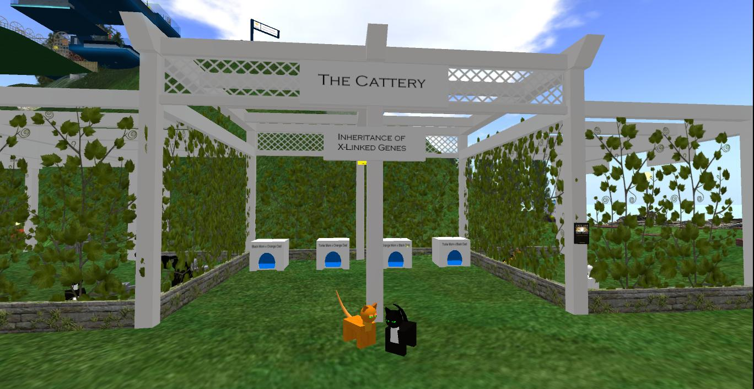](http://slurl.com/secondlife/Genome/135/89/30)

Genes” sign then accept and read the notecard. You do not need the webpage, so click on cancel for that. Clicking on the sign also started a slide show on a screen just below the sign. Click on the screen to advance to the next slide. There are 9 slides. This screen automatically disappears after a while.

After reading the notecard and reviewing the slides you should know that the homozygous dominant allele for orange color ( O O ) gives the orange coat color and the homozygous recessive allele ( o o ) gives a black coat color. Males only have one copy of this allele and so do not have a heterozygous condition. Females have two copies of the allele and can have a heterozygous condition with gives an orange and black cat (a coat color called tortie). Thus, by knowing the phenotype of the cat, you can determine the genotype.

Along the back of the stall are four white boxes where cats live. To see the boxes better, hold down the ALT key again and click on a box. You can use the mouse wheel to zoom in on the boxes and cats. You can also use the camera control (eye icon on bottom toolbar) to move left or right or up and down. From left to right, the crosses from the four boxes are: a black mom x orange dad, tortie mom x orange dad, orange mom x black dad, and tortie mom x black dad. Left click on the left most box and a male and female cat appear in front of the box. The mom is black and the dad is orange. Now go to question 10 on the question pages and complete a Punnett square for this cross.

At this time, make sure your chat box is open by clicking on “nearby chat” on the far left of your bottom toolbar. Now left click on the mom cat and the kittens will appear. The color type for each kitten can be seen in the chat box. Go to question 11 on the question pages and complete the first column of table 3. Click on each of the 3 remaining boxes and click on the mom cats to get the kitten. Then complete the remaining columns in table 3.

The female cats have three possible genotypes: homozygous dominant (OO), homozygous recessive (oo), and heterozygous (Oo). The males have two possible genotypes: dominant (Oy) and recessive (oy). Using these symbols go to question 12 on the questions page and enter the genotype for the mom and dad and each kitten resulting from each cross in the appropriate columns of table 4. Now go to the questions page and complete questions 13 and 14.

A Deadly Tale

Around the corner to the right you will find two different activities in one large stall. These activities are labeled “Whiteout!” and “A Deadly Tale” (see image below).

[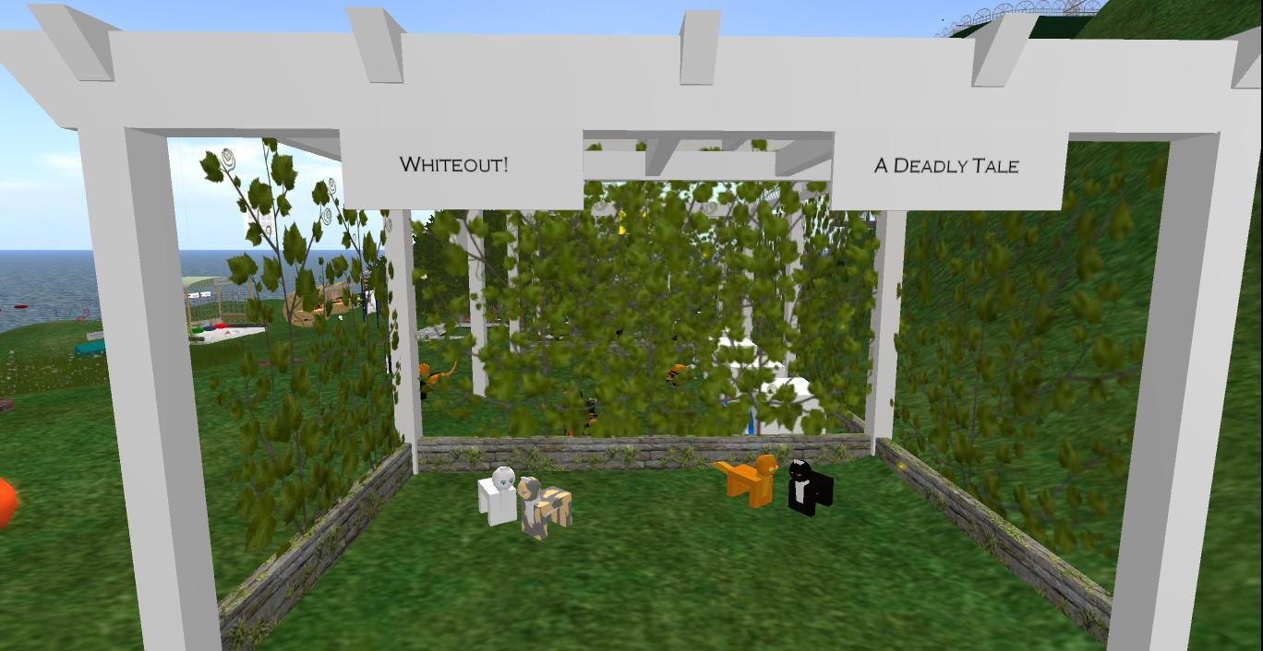](http://slurl.com/secondlife/Genome/148/99/31)

First left click on the sign labeled “A Deadly Tale” and accept and read the notecard. You do not need the webpage, so click on cancel when that is offered. Manx cats have no tail and the allele for the manx condition is dominant. All manx cats are heterozygous for this condition while cats that are homozygous dominant for the manx condition die in utero before birth. Cats that are homozygous recessive for this condition have normal tails.

In this stall there are two pairs of cats. The mom on the right is a manx while the dad on the right has a normal tail. Both cats (dad and mom) on the left are manx cats. Again make sure your chat box is open and click on the mom on the left. Go to Table 5 in question 15 on the question pages and enter the number of manx tail and normal tail kittens are born. Do the same thing for the mom cat on the right and record the kitten phenotype in table 5. Using the data in table 5 answer questions 15, 17, and 18.

Whiteout!

Epistasis is the name for a process where certain genes control the expression of other genes. In the case of Whiteout, a dominant allele for white (W) acts to repress the expression of other cat coat color genes, such as yellow, black, spots, etc. If the cat is homozygous recessive (ww) for the white allele then there is not dominant white allele and other coat colors get expressed.

In this part of the activity a white cat male crosses with a tortie female. Make sure your chat box is open by left clicking on “Nearby Chat” on the far left of the bottom tool bar. Now click on the mom cat and see the coat color and tail type (phenotype) of the 6 kittens. The coat color can be seen in the chat log. Now go to the question 19 on the question page and put the kitten information in table 6. Using the information in table 6, determine the genotypes of the mom and dad for the genes controlling white color, orange color, and spots and complete table 7 in question 20.

Finally right click on the camera icon on the bottom tool bar on your screen. In the top left of the box that appears, click on email and email to **your** professor a photo of yourself at the Cattery. Dr, Perrier’s students can email it to [gperrier@nvcc.edu](mailto:gperrier@nvcc.edu). Also attach your completed question page in a separate email and send it to your professor**. You are done!** Feel free to look around Genome Island.

Question Pages Student name _______________

Avatar name ________________

1. Complete this table:

|  |  |
| --- | --- |
| Markings | Number |
| Unstriped |  |
| Mackeral striped |  |
| Classic striped |  |

2. Are the parents homozygous for the recessive non -Agouti allele, homozygous for the dominant Agouti allele, or heterozygous?

3. How did you derive the answer to question 2?

4. Enter the number of kittens for each color type in table 1 below.

Table 1. Number of kittens by color.

|  |  |  |  |
| --- | --- | --- | --- |
| Kitten color | Grey Dad x Black Mom  (Center) | Grey Dad x Black Mom (Right) | Grey Dad x Black Mom (Left) |
| Gray |  |  |  |
| Black |  |  |  |

5. The alleles are Black and Grey. Which of these two alleles is dominant and which is recessive.

6. Complete table 2 below.

Table 2 Genotypes for each cross

|  |  |  |  |
| --- | --- | --- | --- |
| Cat | Grey Dad x Black Mom  (Center) | Grey Dad x Black Mom (Right) | Grey Dad x Black Mom (Left) |
| Dad |  |  |  |
| Mom |  |  |  |
| Grey Kitten |  |  |  |
| Back Kitten |  |  |  |

7. Why is it that in one cross with the grey parent, there are NO grey kittens, but in the cross with two black parents, a grey kitten appears?

8. The two Grey Dad x Black Mom crosses produce different kittens. Why are they different and which of the two parents in each case is responsible for the difference?

9. There are grey and black kittens with no white spots, grey and black kittens with spots, and even one kitten with extensive white spotting. Explain what type of inheritance might be illustrated here were there are three phenotypes?

10. Punnett square for first pair of cats:

Male Orange

X Y

O -

|  |  |
| --- | --- |
|  |  |
|  |  |

Female

Black X o

X o

11. Enter in table 3 the number of kittens of each type resulting from the crosses

Table 3. Number of kittens of each color type and gender from each cross.

|  |  |  |  |  |
| --- | --- | --- | --- | --- |
| Kitten type | Orange Dad  Black Mom | Black Dad  Orange Mom | Orange Dad  Tortie Mom | Black Dad  Orange Mom |
| Black Male |  |  |  |  |
| Black Female |  |  |  |  |
| Orange Male |  |  |  |  |
| Orange Female |  |  |  |  |
| Tortie Male |  |  |  |  |
| Tortie Female |  |  |  |  |

12. Enter in table 4 the genotype of each cat (dad, mom, and kittens) of each cross.

Table 4. Genotype of each cat

|  |  |  |  |  |
| --- | --- | --- | --- | --- |
| color type | Orange Dad  Black Mom | Black Dad  Orange Mom | Orange Dad  Tortie Mom | Black Dad  Orange Mom |
| Dad |  |  |  |  |
| Mom |  |  |  |  |
| Black Male |  |  |  |  |
| Black Female |  |  |  |  |
| Orange Male |  |  |  |  |
| Orange Female |  |  |  |  |
| Tortie Male |  |  |  |  |
| Tortie Female |  |  |  |  |

13. Why does the heterozygous female (Oo) give you a tortie cat with parts orange and parts black?

14. Why are there no tortie male cats born?

15. Enter in table 5 the number of manx tail and normal tail kittens for each cross.

Table 5. Number of manx and normal tailed kittens.

|  |  |  |
| --- | --- | --- |
| Tail Type | Manx Dad & Manx Mom | Normal Dad & Manx Mom |
| Normal |  |  |
| Manx |  |  |

16. What were the genotypes of the parents in these cross?

Manx tail:

Normal tail:

17 What are the genotypes of the kittens?

Manx tail:

Normal tail:

18. Why are there fewer kittens in the Manx x Manx cross than in the Manx x normal cross?

19. In table 6 below enter the coat color and tail type for the six kittens in Whiteout.

Table 6. Kitten coat color and tail type

|  |  |
| --- | --- |
| Kitten number | Coat color |
| 1 |  |
| 2 |  |
| 3 |  |
| 4 |  |
| 5 |  |
| 6 |  |

20. From the information provided by the kittens coat color and tail type, what is the genotype of the dad and mom in the Whiteout cross for the following genes: White, Orange, and Spots?

|  |  |  |
| --- | --- | --- |
| Gene | Dad Genotype | Mom Genotype |
| White |  |  |
| Orange |  |  |
| Spots |  |  |