Genome Handout Four: Dihybrid Independent Assortment, incomplete dominance, and Maize Kernel Color

Developed by Greg Perrier

Introduction

This document will inform you how to download the Phoenix Firestorm Viewer for Second Life (SL), how to get your own avatar (body) in SL, and how to get to the right location at Genome Island in SL. The last part of this handout provides detailed instructions for completing three different genetic exercises at Genome: Dihybrid Independent Assortment, Incomplete Dominance, and Maize Kernel Color. This worksheet assumes you have a basic understanding of genetic terms. Once you have installed Second Life on a computer, have an avatar, and have arrived at the Genome Island please feel free to look around and see all the fun biology activities that are there.

Downloading Second Life

There are different viewers for SL such as the Second Life webpage viewer (standard viewer), Emerald Viewer, Phoenix Viewer, and Imprudence Viewer. Each viewer has its advantages and disadvantages. The Phoenix Firestorm Viewer (called the Firestorm Viewer) is one of the most stable viewers and is the viewer loaded on the computers at the Manassas Campus. For that reason, the directions for this worksheet assume you are using the Firestorm viewer.

If you have already downloaded the Phoenix Firestorm SL viewer and already have an avatar, log into Firestorm and go to the section below about the Caledon Oxbridge SL Orientation. If you have downloaded Phoenix Firestorm but do not have an avatar, then go to the section below on getting an avatar. If you need to download and install the phoenix firestorm viewer, then go to the following webpage.

http://www.phoenixviewer.com/downloads.php

On this webpage, locate the Firestorm Downloads for either Windows or Mac. Select either Windows or Mac (depends on your computer) and download the file to your computer. Then open and run the downloaded file to install the latest version of Phoenix Firestorm. Once you have installed Firestorm, a Firestorm icon should be on your desktop. You will need the IT people to load Phoenix Firestorm on most NOVA campus computers, but it is loaded on the computers in the general student computer labs on the Manassas Campus (MP 120 and MH 211) and might be available on computers on other campuses.

Getting an Avatar

Once you have downloaded the Firestorm software to your computer you need to get an avatar. To do so, go to the Second Life homepage.

http://secondlife.com/

There you will see a sign that says JOIN NOW. Left click on that. This will take you to a page to select an avatar and open an account. First you will select your initial avatar. Later, you can change this avatar or get a new avatar if you want. You will give Linden Labs (the people who own and run SL) some information about yourself such as your email address and birthdate. You must be at least 16 to legally get an avatar. You will then choose a name for your avatar and a password. You will need these to get into the program. Finally the website will ask you if you want to go into Second Life (SL), say no.
Now you are ready to get into SL using the Firestorm viewer. Click on the Firestorm icon on your desktop and after a few seconds you will see a screen with a black bar along the bottom. There will be a place on the right of the bottom bar to enter you avatar’s name and the password you provided when joining SL. After entering your avatar’s name and password, click on Log In and in about a minute you will find yourself in SL. Often you are initially a cloud, but in a few minutes your should see your avatar. Once in SL, you will find yourself at a welcome center. If you are new to SL, I strongly suggest at this point that you visit the SL orientation at Caledon Oxbridge. If you are familiar with SL, you can skip to the section below on how to get to Genome Island.

How to get to the Caledon Oxbridge Second Life Orientation

A location in SL called Caledon Oxbridge has a great orientation for people new to Second Life. To go to this island in the Firestorm viewer, left click on the map icon on the bottom toolbar (it looks like a map folded in three sections). You should then see a map of whatever area you are in and a box to the right of map that has a legend and small boxes where you can enter text. Delete what text is in the box to the left of the word “Find” and type in “Caledon Oxbridge” (see image next page). Then left click on “Find” and you should see the name of two sims: Caledon Oxbridge and Caledon Oxbridge Village. Left click on Caledon Oxbridge and at the bottom of the box, select the button labeled “Teleport.” This will take you to Caledon Oxbridge University. At the spot where you land are panels that have basic instructions for Second Life, such as how to move. You will see on the floor red arrows leading down the center of a large hall. Follow the arrows out of the hall, across an open plaza, and into another hall. Following the red arrows takes you through six halls in all, each one explaining some aspect of Second Life. It will take you about an hour to read everything and complete all six halls, but the first two halls are the most important for people new to SL. You will learn how to change your avatar’s appearance and will be offered new clothes. Feel free to make the changes and take the clothes. There are often people around the open plaza who are happy to answer questions. Once you have visited Caledon Oxbridge, you can visit New Resident Island and go to their free medieval shopping area to get different clothes and avatar shapes and skins. Use the map icon and the same steps you used to get to Caledon Oxbridge.

Caledon Oxbridge Map
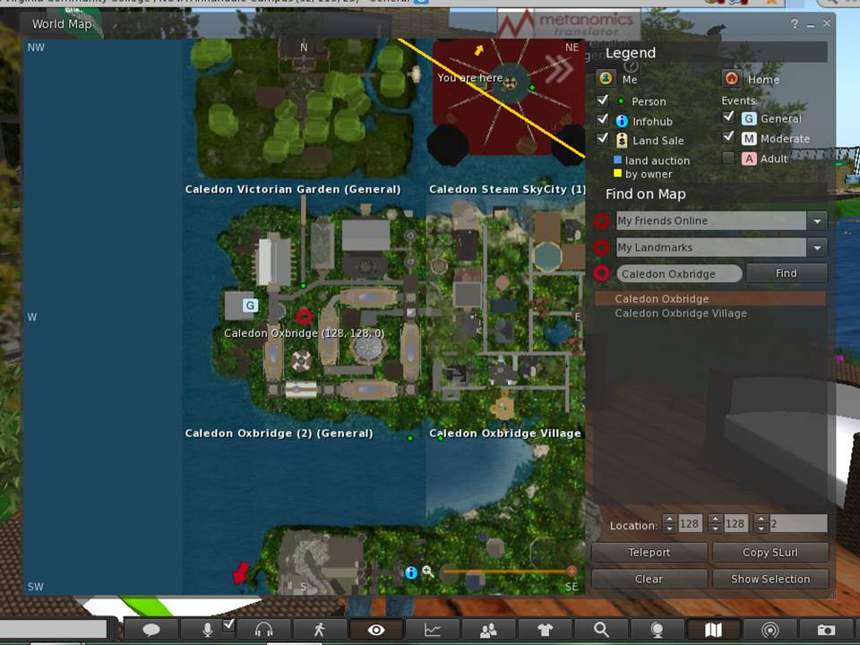

← Caledon Oxbridge

←Teleport

Getting to the Right Location in SL

Once you are ready to move on to Genome Island, left click on the map icon on the bottom toolbar (it looks like a map folded in three sections). You should then see a map of whatever area you are in and a box to the right of map that has a legend and small boxes where you can enter text. Delete what text is in the box to the left of the word “Find” and type in Genome. Then left click on “Genome” in the dropdown box and you will see a map of Genome Island. The red circle is where you will land. Look at the three coordinates at the bottom of the map. They should initially read 128, 128, 0. To land near the Abbey, you should change the coordinates to 158,70, 33 (see image next page). This should have you landing at the right location. Then click on Teleport. You will land to the right of the Abbey. If for some reason you land at the welcome site at Genome Island, you can see the Abbey (a large white building) down the hill. You simply walk or fly to it. Genome Island is run by Texas Wesleyan University and the administrator is Dr. Mary Clark (avatar is Max Chatnoir).

Genome Map

← Genome

← 158, 70, 33

← Teleport

At this point you will need to move around Genome Island in SL. The orientation at Caledon Oxbridge explains how to do this in detail. If you have skipped this orientation, however, here are a few instructions on how to move. To walk simply use the arrow keys on your keyboard. The up key moves you forward, the down key moves you backwards, and the left and right keys turn you. Take 20 seconds and practice moving around. In SL, your avatar can walk, run, and fly. To change from walking to running or flying, left click on the walking person icon on the bottom toolbar. This icon looks a lot like the walk symbol at a crosswalk. A small box appears on your screen with three icons across the bottom - walk, run, and fly - from left to right, respectively. Click on the fly icon and your avatar rises in the air. Use the dashed arrows on the right of the box to move higher and lower. You can use the arrow keys on your keyboard or the arrows in the box on your screen to move your avatar in the fly mode.

Once you are at the Abbey you should create a landmark so you can return here easily. To create a landmark, right click on World on the top toolbar and in the drop down box, select “Landmark this Place.” The next time you want to come to the Abbey at Genome Island, click on your inventory (suitcase icon on the bottom toolbar) and select Landmarks, and click on Genome Island. You will get an option to teleport to Genome Island. This will return you to the Abbey.
Before starting the activity, there are a few setting changes that might improve your experience in SL. If you would like to hear sounds better, left click on the speaker icon located in the top right of your screen just below the red box with the X. Make sure all the sounds options are checked and adjust the volume for each as needed. If you find the SL program is running slowly, stalling, or crashing often you can reduce the graphics quality and speed. To do this, left click on the word Avatar in the top left corner of your screen. In the drop down box select Preferences. Under Preferences, select Graphics. Select General under Graphics and you should see a scale for Quality and Speed Performance. Set this to low. To exit Firestorm click on the red X at the top right of your screen.
.
SL is like a large city. At any time there are about 50,000 people logged in. Most of those people are nice and respectful, but like any city, there are people who might bother you. As long as you stay on the Genome Island, it is unlikely anyone will bother you. If they do, email me their name and simply log out of SL and return later.

The Activity Starts on the Next Page

Genome Four Activity

Exercise 1 Independent Assortment – This experiment will demonstrate how genes on different chromosomes separate independently during anaphase of meiosis I. Independent assortment of homologous chromosomes was one of Mendel’s major findings. If you need to review independent assortment go inside the Abbey and look at slideshow 4 on the back of the right wall. Left click on the slides to advance it. To get to the correct flowerbed, walk to the right of the Abbey. Because there is a short wall on the right side of the Abbey, you must walk through the white arched arbor (see photo below). Once through the arbor, the circular independent assortment flowerbed is directly in front of you.

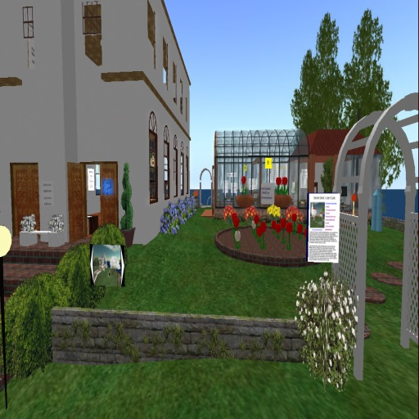

You will have plants with two traits (flower color and plant height) each having a dominant and recessive phenotype. The dominant phenotypes are red flowers and tall plants while the recessive phenotypes are white flowers and short plants. Standing at the front of the flowerbed, with the greenhouse behind the flowerbed, you will see a floating flower pot on the left side. This flowerpot contains the two parent plants; one plant is homozygous dominant for both traits and thus is red and tall. The genotype for this plant is RRTT. The other plant is homozygous recessive for both traits and its genotype is rrtt. These two parent plants were crossed producing the F1 generation that is all heterozygous (RrTt). The heterozygous F1 generation is the four plants in the flowerpot on the left. In this exercise, you will be crossing a heterozygous F1 plant with another heterozygous F1 plant and producing 16 seeds that have been planted to give the 16 plants in the large flowerbed. These 16 plants are the F2 generation. On the next page is show a Punnett Square for a cross between two dihybrid ((heterozygous (=hybrid) for two (=di) traits)) plants. Any F2 plant having at least one allele for dominant color (R) will be red and any F2 plant having at least one allele for dominant height (T) will be tall. Using this information and the Punnett Square, answer question one through five on the questions page in the back of this handout.

Punnett Square for dihybrid x dihybrid cross.

 | RT | Rt | rT | rt
RT | RRTT | RRTt | RrTT | RrTt
Rt | RRTt | RRtt | RrTt | Rrtt
rT | RrTT | RrTt | rrTT | rrTt
rt | RrTt | Rrtt | rrTt | rrtt

Now open up the Excel file provided by your professor. The bottom of this Excel spreadsheet has three tabs, one for Independent Assortment, one for Dihybrid Test Cross and one for Maize Kernel Color. Make sure you are on the spreadsheet for Independent Assortment. It will say “Independent Assortment in a Dihybrid Cross” at the top of the spreadsheet. Next, open up your chat window. To do this click on “Nearby Chat” on the bottom toolbar, near the left side of your screen. You should see a chat box appear on your screen. For this to work correctly, you need to be very close to the flowerbed, so move so that you are touching or just inside the flowerbed. Now you are ready to collect data!

Standing directly in front of the flower bed, left click on the ground in the flowerbed and you should see 16 lines of data appear in your chat window. There is a line for each flower in the flowerbed. Carefully highlight these 16 lines and paste them into column B of trial 1 on the Excel spreadsheet. There are four different possible phenotypes from the dihybrid cross: tall-red, short-red, tall-white, and short white. For each row in trial 1, put a 1 in the column for the phenotype of that plant. So, if your first plant is tall-white, then put a 1 in the column under tall-white (column D). If you have entered the data correctly, the total at the bottom of trial 1 should read 16. If it does not, then correct your error. Return to the flowerbed and again click on it. Repeat the steps above for trials 2 and 3 on the Excel sheet.

Note that at the top of the Excel spreadsheet in columns I to M that the results for the three trials are summed and a mean calculated. In the table just below this, this mean is then used to calculate a Chi Square number. This number allows you to compare the expected results (9 tall-red, 3 short-red, 3 tall-white, and 1 short-white) with the observed results from your 3 trials to determine if your observed results are close enough to the expected results to support the hypothesis that we had independent assortment in a dihybrid cross. The Chi Square calculations on the Excel spreadsheet give you a number (found in box N20) that you then compare to a number from the Chi Square table located in the greenhouse behind the flowerbed. You do not need to look at the table because the table value is 7.18 for 3 degrees of freedom and at a probability of 0.05. If your calculated Chi Square number is less than or equal to 7.18, you accept the hypothesis and say the dihybrid cross demonstrated independent assortment. If the calculated Chi Square number is greater than 7.18, you reject the hypothesis.

Return to the question page at the end of this handout and complete the remaining questions for the independent assortment exercise.

Exercise 2: Intermediate (Incomplete) Dominance – The Intermediate dominance flowerbed is located on the other side of the Abbey. To get there, go out to the front of the Abbey and walk over to some wooden stairs. Go up the stairs and the first flowerbed to the right is the one for intermediate dominance.

For any characteristic where there is one dominant and one recessive allele there will be three possible genotypes: homozygous dominant, heterozygous, and homozygous recessive. In most cases the dominant allele has complete dominance and then there are only two possible phenotypes. The homozygous dominant and heterozygous genotypes result in the dominant phenotype and the homozygous recessive genotype results in the recessive phenotype. In this case, the dominant allele gene codes for a protein that carries out the dominant function. For example a red flower has a protein that absorbs all wavelengths of light except red, which it reflects. The recessive allele gene is altered and does not code for the correct protein and the function of the correct protein is not carried out. For example a white flower, lacks the protein pigment that reflects red wavelengths of light.

In intermediate or incomplete dominance, the dominant and recessive allele of the heterozygous genotype both code for a functional protein. The mixture of these two proteins results in a phenotype that is intermediate between the dominant and recessive phenotypes. Thus, alleles that exhibit incomplete dominance have the three genotypes and each genotype has a different phenotype resulting in the dominant, intermediate, and recessive phenotypes. A cross of the heterozygous F1 generation organisms results in an F2 generation that is 25% homozygous dominant (dominant phenotype), 50% heterozygous (intermediate phenotype) and 25% homozygous recessive (recessive phenotype). The Punnett Square below shows a simple cross between two heterozygous plants having a dominant (R) allele and a recessive (r) allele.
 | R | r
R | RR | Rr
r | Rr | rr

For this activity go to the flower bed closest to the front of the Abbey, left click on the white sign that reads “Intermediate Dominance.” You get a blue box to accept a notecard and about 3 seconds later you get another blue box allowing you to go to a webpage. Unfortunately, the second box will cover the first box. To return to the notecard box, simply click “Cancel” on the webpage box. Now accept and read the notecard for a better understanding of incomplete dominance. You do not need to go to the webpage for an Excel file, but rather, use the Excel file provided for Genome Handout 4. Once you have opened this Excel sheet, go to the tab on the bottom of the spreadsheet that reads “Incomplete.”

Just in front of the sign that reads “Intermediate Dominance” you will see two parent plants: a homozygous dominant plant with a red flower and a homozygous recessive plant with a white flower. Just in front of these two plants, you will see four plants with pink flowers. These are the F1 crosses from the homozygous parents and they are all heterozygous and have the intermediate phenotype for flower color (pink). You will be doing crosses of the heterozygous plants to get an F2 generation that you can see in the flower bed.

First have the Excel spreadsheet open and make sure you are on the spreadsheet page for the incomplete dominance exercise. There are two other spreadsheets in the file, one for Independent Assortment and one for Maize Kernels. Next open your chat window. To do this you left click on the tab that says “ Nearby Chat” located near the bottom left of your screen. You should see a chat box appear on your screen. Now click on the soil in the flowerbed for incomplete dominance. You will see the results for the 16 F2 generation plants in the flowerbed appear in the chat window. Carefully highlight and copy those and then paste them into the Phenotype column for Trial 1 on the Excel spreadsheet. Now for each of the 16 F2 plants, put a 1 in the column for their flower color. If the plant has a red flower, then for that row, put a 1 in the red flower column. Do this for all 16 plants. Repeat this exercise 3 more times until you have the results for all 4 trails in your Excel spreadsheet. Note the total box at the bottom of each trial should read 16. If it is less than 16, you missed a row. Go back and fill it in. The Excel file will automatically transfer your results to the box that takes a total for all 4 trials and calculates the ratio and percent for each phenotype. The percent should approach 25% red, 50% pink, and 25% white or a 1 to 2 to 1 ratio. Now go to the back of the handout and answer the question for the section on incomplete dominance.

Exercise 3 - Maize (corn) Kernel Color Genetics – Kernel color in maize (corn) is not controlled by one gene with a dominant and a recessive allele, but rather, it is controlled by several genes and two different pigments. One of the pigments (anthocyanins) is located in a thin layer (the aleurone) under the seed pericarp (skin) and can be either red or purple. The other pigment, carotenoids, is found deeper in the kernel under the aleurone in the endosperm (see the diagram below). Carotenoids range from pale to deep yellow.

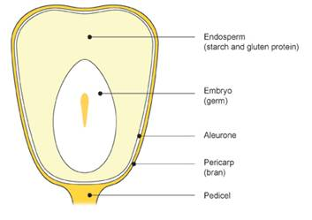
Source: http://www.carolina.com/images/teacher-resources/carolina_tips/nov-2013/corn-kernel-diagram.jpg

Endosperm color is controlled by the action of two alleles: the dominant allele (Y), which produces a yellow pigment, and the recessive (y), which produces no pigment. The pigments in the aleurone are produced in a three step process, with each step catalyzed by an enzyme. It is the presence or absence of functional enzymes that determines the color of the aleurone pigments. Each enzyme is associated with a dominant allele, which produces a functioning enzyme, and a recessive allele, the does not produce a functioning enzyme. The three step process is illustrated below.

Precursor => colorless product => red pigment => purple pigment
↑ ↑ ↑
C enzyme R enzyme P enzyme

If at least one allele for the first enzyme is dominant then the colorless product is produced. If at least one allele for each of the first two enzymes is dominant then the red pigment is produced. If at least one allele for each of the first three enzymes is dominant, then the purple pigment is produced. If both alleles for the first enzyme are recessive, then the colorless product is not produced and the aleurone has no color. If the colorless product is produced, but both alleles for the second enzyme are recessive, then the red pigment is not produced and the aleurone again has no color. If the red pigment is produced, but both alleles for the third enzyme are recessive, then the purple pigment is not produced and the aleurone is red. Only when there is at least one dominant allele for each of the three enzymes is the purple pigment produced.

The C gene controls the formation of the first enzyme. C denotes the dominant allele and c denotes the recessive allele. If this gene is homozygous dominant (CC) or heterozygous (Cc) (has at least one dominant allele) then the colorless product is produced. If it is homozygous recessive (cc), then no pigments can be made. The R gene controls the formation of the second enzyme. R denotes the dominant allele and r denotes the recessive allele. If this gene is homozygous dominant (RR) or heterozygous (Rr) then the colorless product is turned into a red pigment. If the R gene is homozygous recessive (rr) then no pigment is formed. The P gene (Pr gene in the notecards) controls the formation of the third enzyme. P denotes the dominant allele and p denotes the recessive allele. If this gene is homozygous dominant (PP) or heterozygous (Pp) and the red pigment has been formed, then the red pigment is changed into the purple pigment. Note that even if the corn kernel has a dominant P allele that the kernel can have no pigment in the aleurone if the R or C alleles are homozygous recessive.

Four possible phenotypes are possible.

1. White: If both alleles for the Y (controls endosperm color), C, R, and P genes are recessive, then the kernel is has no pigments and is white. The genotype is (yy, cc, rr, pp). This phenotype can also occur if at least one allele for the C gene is dominant, but both alleles for the R and P genes are recessive. An example genotype is ((yy, Cc, rr, pp).

2. Yellow: If the Y gene has at least one dominant allele but both alleles for the C, R, and P genes are recessive, then the kernel is yellow. The two possible genotypes are (Yy, cc, rr, pp) and YY, cc, rr, pp). This phenotype can also occur if at least one allele for the C gene is dominant, but both alleles for the R and P genes are recessive. An example genotype is ((Yy, Cc, rr, pp).

3. Red: The red pigment in the aleurone masks the pigments in the endosperm and so the phenotype and genotype of the Y gene can be ignored in this case. In this case both the C and R genes have at least one dominant allele and the P alleles are homozygous recessive. An example genotype would be (Yy, Cc, Rr, pp)

4. Purple: The purple pigment in the aleurone masks the pigments in the endosperm and so the phenotype and genotype of the Y gene can also be ignored in this case. When the kernel is purple the C, R, and P genes each have at least one dominant allele (homozygous dominant or heterozygous). An example genotype would be (Yy, Cc, Rr, Pp).

With this introductory explanation you should be able to work out the genetics of the various kernels on the three different maize ears on the table located in front of the garden as well as determine the parent plants that produced each ear.

First you will determine the ratio of the different colored kernels on each of the three ear of maize on the table. Start by facing the table in front of the garden. Open the Excel file your professor provided with this worksheet and make sure you are on the spreadsheet for Maize. Now you will zoom in on the ear of maize with one locus. To do this put your curser over the ear of maize and hold down the ALT key. Your curser should look like a magnifying glass with a + in the middle of it. You can now zoom in very close on the ear. Count all the dark yellow and the purple kernels in two rows on the one locus maize ear and enter the number in the appropriate box on the Excel spreadsheet. The spreadsheet will sum the results and calculate a ratio for you.

Here are a few suggestions to make counting the kernels by color easier. If you hold the curser over the kernels you get a dark box at the curser that makes it hard to count kernels. So keep the curser away from the kernels. Note the row when you begin so you can find it again to count other colors. Make sure the two rows are different. The rows were pasted on the ear like wallpaper and there are repeating patterns. Do your best to distinguish between the various colors, sometimes it is hard. Note the kernels near the ends of the ear are often very narrow. Select rows for which it is easier to distinguish the colors.

Once you have counted the dark yellow and purple kernels in two rows of the one locus ear of maize, continue on the two loci ear and then the three loci ear. Enter the number of kernels by color into the Excel spreadsheet and see the ratios of the kernels by color. Round the ratios to the nearest whole number (no numbers after the decimal).

One Locus: Left click on the maize ear in the back right of the table and open the notecard. This should say “One Locus.” If not, you have clicked on the wrong maize ear. Read the notecard. This ear has both purple and dark yellow kernels. Note that his ear has only one pair of segregating alleles. The dominant allele gives purple kernels and the recessive allele gives dark yellow kernels. Go to the question page and answer the first three questions in the Maize section. This answer is not as obvious as it looks. You must consider the genetics of the pigment of the endosperm, each step in the formation of the aleurone pigments, and the genes for the enzymes that control the steps for forming the aleurone pigments.

Two Loci: Now click on the maize ear closest to the front of the table and get the notecard. This ear should be labeled “Two Loci.” This ear has three different colored kernels: white, yellow, and purple. In this ear of corn, there are two pairs of alleles segregating. These are the C gene alleles that code for the enzyme that forms the colorless product and the Y gene alleles that code for the yellow pigment in the endosperm. The dominant allele C puts color in the aleurone of the kernel and produces a purple kernel. The recessive allele c stops the formation of any pigments in the aleurone, so the color of the kernel is the color of the deeper endosperm. In the endosperm the dominant allele Y produces a yellow carotenoid pigment, and the kernel is yellow (in the absence of color in the aleurone). The recessive allele does not produce this pigment, so the kernel is white. Using this information, answer the questions in the two loci section of the Maize part of the question pages.

Three Loci: Now click on the maize ear located at the back left of the table and get the notecard. This ear should be labeled “Three Loci.” Again look closely at the maize ear. You will see there are four colors of kernels: white, yellow, red, and purple. This is the result of independent assortment at three different loci. Three genes are involved: Y, C, and P (listed as Pr in the notecard). The dominant Y allele (Y) codes for the yellow pigment in the endosperm. The recessive Y allele (y) does not make this pigment and thus the endosperm is white. The dominant C allele (C) codes for the enzyme that forms the colorless product. The recessive C allele (c) does not make this enzyme so that the colorless product is not formed. The dominant P allele (P) codes for the enzyme that converts the red pigment to the purple pigment. The recessive P allele (p) does not form the correct enzyme and thus the red pigment is not modified and no purple pigment is formed. The R alleles are homozygous dominant so that if there is a dominant C allele, the kernel is red and if there is both a dominant C allele and a dominant P allele, the kernel is purple. If the C allele is recessive, the kernel has the color of the endosperm, either white or yellow. Now go to the three loci section of the Maize part of the question pages and answer the questions for the three loci ear.

Question Page Student name _____________

Avatar name ______________
Dihybrid Independent Assortment Questions

1. What kind of assortment does the F2 generation exhibit? Which of Mendel’s laws does it support?

2. What are the genotypes of both of the first parent plants?

3. Why do the F1 generation plants only contain tall plants with red flowers? Why are there no short plants or white flowers?

4. According to the activity, what is the genotype for the F1 Generation? What is their phenotype?

5. From the Punnett Square, what is the ratio of short-white flower plants to short-red flower plants, to tall-white flower plants, to tall-red flower plants?

short-white flower
short-red flower
tall-white flower
tall-red flower

5. From the Excel file, find the ratio of plants from your data of each possible phenotype:

Tall Red

Short Red

Tall White

Short White

6. Does your observed phenotypic results support / refute Mendel’s hypothesis? Why or why not?

Intermediate Dominance Exercise Questions

1. Why do the heterozygous plants have pink flowers?

2. What is the mean for the number of red, pink, and white flowers that resulted from the four crosses?

Red Pink White

3. What is the phenotype ratio (red : pink : white) in the F2 generation?

Red Pink White

4. Why does the F2 generation have the same phenotype and genotype ratios?

5. What phenotype ratio would you expect if the alleles did not show incomplete dominance?

6. What might be an indication that alleles for a trait exhibited incomplete dominance?

Maize Kernel Color Questions

One Locus

1. What is the ratio of yellow to purple kernels in the one locus maize ear?

Yellow Purple
2. What is a possible genotype for the yellow kernels on the one locus corn ear?

- What is a possible genotype for the purple kernels on the one locus corn ear?

4. If all the kernels had the same parents, what is the most probable genotype for the parents of the one locus corn ear kernels?

YYCCRrPP x YYCCRrPP

Two Loci

1. What is the ratio of white to yellow to purple kernels in the 2 loci ear?

White Yellow Purple

2. What is a possible genotype for the white kernels on the two loci corn ear?

3. What is a possible genotype for the yellow kernels on the two loci corn ear?

4. What is a possible genotype for the purple kernels on the two loci corn ear?

5. If all the kernels had the same parents, what is the most probable genotype for the parents of the two loci corn ear kernels?

Three Loci

1. What is the ratio of yellow to red, to white to purple kernels?

White Yellow Red Purple

2. What is a possible genotype for the white kernels on the three loci corn ear?

3. What is a possible genotype for the yellow kernels on the three loci corn ear?

4. What is a possible genotype for the red kernels on the three loci corn ear?

5. What is a possible genotype for the purple kernels on the three loci corn ear?

6. If all the kernels had the same parents, what is the most probable genotype for the parents of the two loci corn ear kernels?

