Genome Handout Three: Test Cross, Incomplete Dominance, and Linked Genes
Developed by Greg Perrier

Introduction

This document will inform you how to download the Phoenix Firestorm Viewer for Second Life (SL), how to get your own avatar (body) in SL, and how to get to the right location at Genome Island in SL. The last part of this handout provides detailed instructions for completing three different genetic exercises at Genome: Test Crosses, Incomplete Dominance, and Linked Genes. Once you have installed Second Life on a computer, have an avatar, and have arrived at the Genome Island please feel free to look around and see all the fun biology activities that are there.

Downloading Second Life
There are different viewers for SL such as the Second Life webpage viewer (standard viewer), Emerald Viewer, Phoenix Viewer, and Imprudence Viewer. Each viewer has its advantages and disadvantages. The Phoenix Firestorm Viewer (called the Firestorm Viewer) is one of the most stable viewers and is the viewer loaded on the computers at the Manassas Campus. For that reason, the directions for this worksheet assume you are using the Firestorm viewer.

If you have already downloaded the Phoenix Firestorm SL viewer and already have an avatar, log into Firestorm and go to the section below about the Caledon Oxbridge SL Orientation. If you have downloaded Phoenix Firestorm but do not have an avatar, then go to the section below on getting an avatar. If you need to download and install the phoenix firestorm viewer, then go to the following webpage.

http://www.phoenixviewer.com/downloads.php

On the webpage, find the Firestorm Downloads for either Windows or Mac. Select either Windows or Mac (depends on your computer) and download the file to your computer. Then open the downloaded file to install the latest version of Phoenix Firestorm. Once you have installed Firestorm, a Firestorm icon should be on your desktop. You will need the IT people to load Phoenix Firestorm on most NOVA campus computers, but it is loaded on the computers in the general student computer labs on the Manassas Campus (MP 120 and MH 211) and might be available on computers on other campuses.

Getting an Avatar
Once you have downloaded the Firestorm software to your computer you need to get an avatar. To do so, go to the Second Life homepage.
http://secondlife.com/
There you will see a sign that says JOIN NOW. Left click on that. This will take you to a page to create an avatar and open an account. First you will select your initial avatar. Later, you can change this avatar or get a new avatar if you want. You will give Linden Labs (the people who own and run SL) some information about yourself such as your email address and birthdate. You will then choose a name for your avatar and a password. You will need these to get into the program. Finally the website will ask you if you want to go into Second Life (SL), say no.
Now you are ready to get into SL using the Firestorm viewer. Click on the Firestorm icon on your desktop and after a few seconds you will see a screen with a black bar along the bottom. There will be a place on the right of the bottom bar to enter you avatar’s name and the password you provided when joining SL. After entering your avatar’s name and password, click on Log In and in about a minute you will find yourself in SL. Often you are initially a cloud, but in a few minutes your should see your avatar. Once in SL, you will find yourself at a welcome center. If you are new to SL, I strongly suggest at this point that you visit the SL orientation at Caledon Oxbridge. If you are familiar with SL, you can skip to the section below on how to get to Genome Island.

How to get to the Caledon Oxbridge Second Life Orientation
A location called Caledon Oxbridge has a great orientation for people new to Second Life. To go to this island in the Firestorm viewer, left click on the map icon on the bottom toolbar (it looks like a map folded in three sections). You should then see a map of whatever area you are in and a box to the right of map that has a legend and small boxes where you can enter text. Delete what text is in the box to the left of the word “Find” and type in “Caledon Oxbridge” (see image below). Then left click on “Find” and you should see the name of two sims: Caledon Oxbridge and Caledon Oxbridge Village. Left click on Caledon Oxbridge and at the bottom of the box, select the button labeled “Teleport.” This will take you to Caledon Oxbridge University. At the spot where you land are panels that have basic instructions for Second Life, such as how to move. You will see on the floor red arrows leading down the center of a large hall. Follow the arrows out of the hall, across an open plaza, and into another hall. Following the red arrows takes you through six halls in all, each one explaining some aspect of Second Life. It will take you about an hour to read everything and complete all six halls, but the first two halls are the most important for people new to SL. You will learn how to change your avatar’s appearance and will be offered new clothes. Feel free to make the changes and take the clothes. There are often people around the open plaza who are happy to answer questions. Once you have visited Caledon Oxbridge, you can visit New Resident Island and go to their free medieval shopping area to get different clothes and avatar shapes and skins. Use the map icon and the same steps you used to get to Caledon Oxbridge.
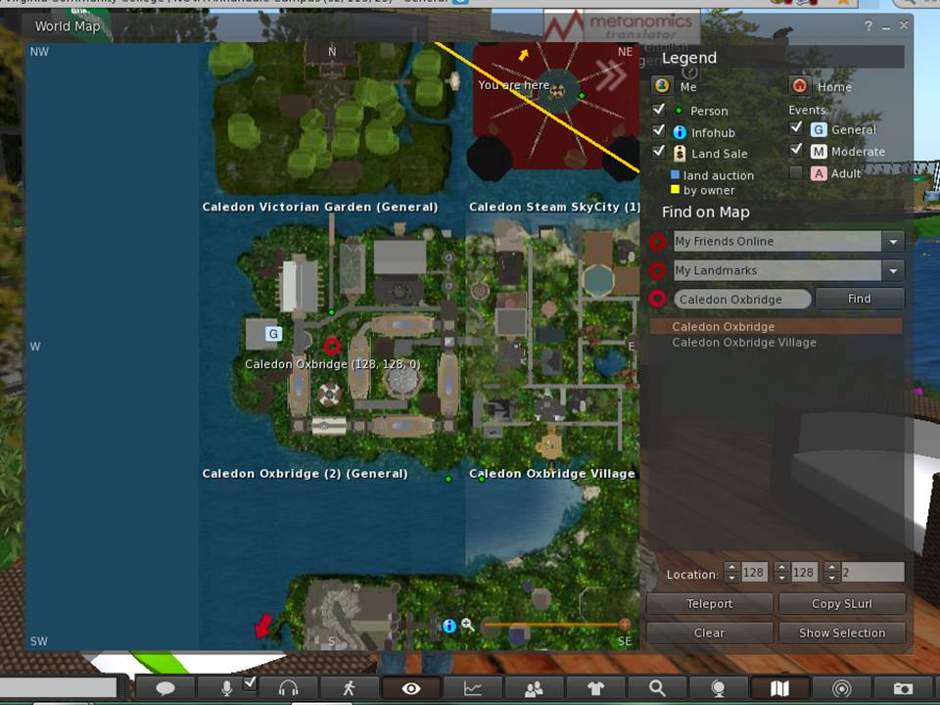

← Caledon Oxbridge

← Teleport

Getting to the Right Location in SL
Once you are ready to move on to Genome Island, left click on the map icon on the bottom toolbar (it looks like a map folded in three sections). You should then see a map of whatever area you are in and a box to the right of map that has a legend and small boxes where you can enter text. Delete what text is in the box to the left of the word “Find” and type in Genome. Then left click on “Genome” in the dropdown box and you will see a map of Genome Island. The red circle is where you will land. Look at the three coordinates at the bottom of the map. They should initially read 128, 128, 0. To land near the Abbey, you should change the coordinates to 158, 70, and 33 (see image below). This should have you landing at the right location. Then click on Teleport. You will land to the right of the Abbey. If for some reason you land at the welcome site at Genome Island, you can see the Abbey (a large white building) down the hill. You simply walk or fly to it. Genome Island is run by Texas Wesleyan University and the administrator is Dr. Mary Clark (avatar is Max Chatnoir).

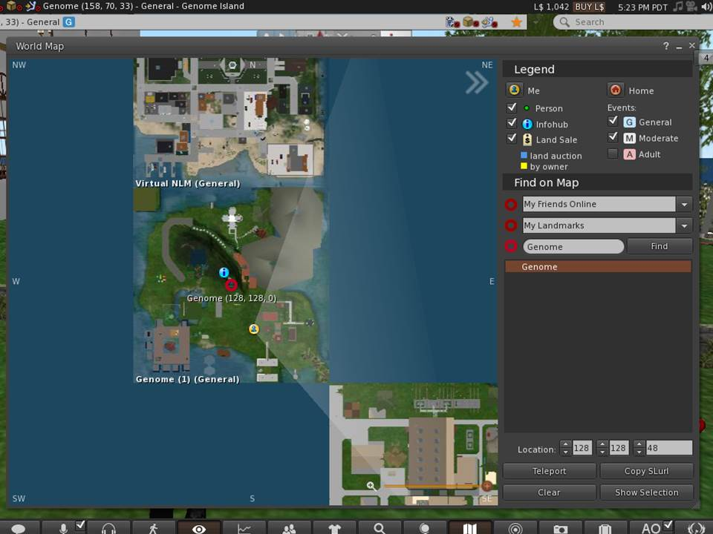

← Genome

← 158, 70, 33
← Teleport

At this point you will need to move around Genome Island in SL. The orientation at Caledon Oxbridge explains how to do this in detail. If you have skipped this orientation, however, here are a few instructions on how to move. To walk simply use the arrow keys on your keyboard. The up key moves you forward, the down key moves you backwards, and the left and right keys turn you. Take 20 seconds and practice moving around. In SL, your avatar can walk, run, and fly. To change from walking to running or flying, left click on the walking person icon on the bottom toolbar. This icon looks a lot like the walk symbol at a crosswalk. A small box appears on your screen with three icons across the bottom, walk, run, and fly from left to right, respectively. Click on the fly icon and your avatar rises in the air. Use the dashed arrows on the right of the box to move higher and lower. You can use the arrow keys on your keyboard or the arrows in the box on your screen to move your avatar in the fly mode.
Once you are at the Abbey you should create a landmark so you can return here easily. To create a landmark, right click on World on the top toolbar and in the drop down box, select “Landmark this Place.” The next time you want to come to the Abbey at Genome Island, click on your inventory (suitcase icon on the bottom toolbar) and select Landmarks, and click on Genome Island. You will get an option to teleport to Genome Island. This will return you to the Abbey.
Before starting the activity, there are a few setting changes that might improve your experience in SL. If you would like to hear sounds better, left click on the speaker icon located in the top right of your screen just below the red box with the X. Make sure all the sounds options are checked and adjust the volume for each as needed. If you find the SL program is running slowly, stalling, or crashing often you can reduce the graphics quality and speed. To do this, left click on the word Avatar in the top left corner of your screen. In the drop down box select Preferences. Under Preferences, select Graphics. Select General under Graphics and you should see a scale for Quality and Speed Performance. Set this to low.
SL is like a large city. At any time there are about 50,000 people logged in. Most of those people are nice and respectful, but like any city, there are people who might bother you. As long as you stay on the Genome Island, it is unlikely anyone will bother you. If they do, email me their name and simply log out of SL and return later.

The Activity Starts on the Next Page

Genome Three Activity
Introduction
This Second Life handout provides instructions for completing three of the five different genetic activities at Genome Island that are each associated with a specific flowerbed. You landed in front of the Abbey (the large white building). Facing the Abbey, four flower beds are located on the left side of the Abbey and one flower bed is located on the right side of the Abbey. The four activities along the left side of the Abbey are (from the back to the front of the Abbey) Linked Genes, Dihybrid Test Cross, Test Cross, and Intermediate (Incomplete) Dominance. The activity on the right side of the Abbey is Independent Assortment in a Dihybrid Cross. In this handout you will complete the Test Cross, Incomplete Dominance, and Linked Genes activities. Genome handout four covers the other two flowerbeds. Mendel used test crosses, however, he was unaware of linked genes and incomplete dominance. These aspects of genetics were discovered later by other researchers.
At each of the three flowerbeds you will be offered a notecard, and, except at the test cross flowerbed, you will also be offered an excel spreadsheet. You should click “Accept” to get the offered notecard, but do not go to the webpage to get the Excel file. Instead use the Excel spreadsheet provided by your professor. How to download the notecards is explained later under each exercise. The notecards will provide invaluable information about the activity and in some instances may provide answers to the questions found at the end of this handout. The provided Excel spreadsheets will be formatted to accepted your test results from the crosses you will run. It will also complete many of the calculations needed to analyze the results. When doing the activity, you should complete these spreadsheets. The notecards will be stored in your inventory (suitcase icon on bottom toolbar) in the folder labeled “Notecards” and you can always access them from there.

To start, walk to the left of the Abbey, go up some wooden steps and walk along the wooden walkway (see image on next page). Go to the second flowerbed, which will be labeled “Tests Cross.”

Exercise 1: Test Cross - For alleles where there is complete dominance (the dominant allele is expressed and the recessive allele is not expressed), both the homozygous dominant organism and the heterozygous organism have the dominant phenotype. A test cross allows one to determine between these two possible genotypes for an organism with the dominant phenotype.

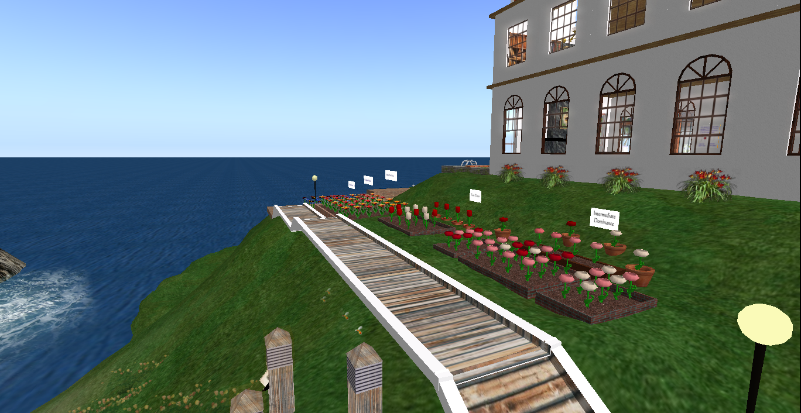

To start this activity, left click on the white sign that reads “Test Cross” and accept the notecard that is offered in a blue box on your screen. You will see a notecard appear. Read the notecard to develop a better understanding of the test cross. In this case red is the dominant phenotype and white is the recessive phenotype. The dominant allele is expressed as R and the recessive allele is expressed as r. Just below the white sign and just outside the flowerbed you will see four plants with red flowers. The genotype of these flowers is unknown. Each plant can be homozygous dominant (RR) or heterozygous (Rr). For the test cross, the plant with an unknown genotype is crossed with a homozygous recessive (rr) plant that has the white flower phenotype and so can be easily identified. If the plant with the unknown genotype is homozygous dominant all the F1 generation will be heterozygous (Rr) and be red. If the plant with the unknown genotype is heterozygous than half (on average) of the F1 offspring will be heterozygous and have red flowers and half will be homozygous recess and have white flowers. If there are any white flowers in the F1 generation, then you know the parent with the unknown genotype is heterozygous.

Now go to the Question Pages at the back of this handout and read the 6 questions concerning the Test Cross. Then, left click on the left-most red parent plant just behind the flower bed and in question 3, note whether it is homozygous dominant or heterozygous. Now repeat this for the plant just to the right of the first parent plant and record the result under question 4. Continue to the right until the genotype of all four parent plants is known and recorded in questions 3 to 6 on the question page. Before moving to Exercise 2, complete all the questions for the Test Cross activity.

Exercise 2: Intermediate (Incomplete) Dominance – For any characteristic where there is one dominant and one recessive allele there will be three possible genotypes: homozygous dominant, heterozygous, and homozygous recessive. In most cases the dominant allele has complete dominance and then there are only two possible phenotypes. The homozygous dominant and heterozygous genotypes result in the dominant phenotype and the homozygous recessive genotype results in the recessive phenotype. In this case, the dominant allele gene codes for a protein that carries out the dominant function. For example a red flower has a protein that absorbs all wavelengths of light except red, which it reflects. The recessive allele gene is altered and does not code for the correct protein and the function of the correct protein is not carried out. For example a white flower, lacks the protein pigment that reflects red wavelengths of light.
In intermediate or incomplete dominance, the dominant and recessive allele of the heterozygous genotype both code for a functional protein. The mixture of these two proteins results in a phenotype that is intermediate between the dominant and recessive phenotypes. Thus, alleles that exhibit incomplete dominance have the three genotypes and each genotype has a different phenotype resulting in the dominant, intermediate, and recessive phenotypes. A cross of the heterozygous F1 generation organisms results in an F2 generation that is 25% homozygous dominant (dominant phenotype), 50% heterozygous (intermediate phenotype) and 25% homozygous recessive (recessive phenotype). The Punnett Square below shows a simple cross between two heterozygous plants having a dominant (R) allele and a recessive (r) allele.
 | R | r
R | RR | Rr
r | Rr | rr

For this activity go to the flower bed closest to the front of the Abbey, left click on the white sign that reads “Intermediate Dominance.” You get a blue box to accept a notecard and about 3 seconds later you get another blue box allowing you to go to a webpage. Unfortunately, the second box will cover the first box. To return to the notecard box, simply click “Cancel” on the webpage box. Now accept and read the notecard for a better understanding of incomplete dominance. You do not need to go to the webpage for the provided Excel file, but rather, use the Excel Spreadsheet provided for Genome Handout 3. Once you have opened this Excel sheet, go to the tap on the bottom of the spreadsheet that reads “Incomplete.”
Just in front of the sign that reads “Intermediate Dominance” you will see two parent plants: a homozygous dominant plant with a red flower and a homozygous recessive plant with a white flower. Just in front of these two plants, you will see four plants with pink flowers. These are the F1 crosses from the homozygous parents and they are all heterozygous and have the intermediate phenotype for flower color (pink). You will be doing crosses of the heterozygous plants to get an F2 generation that you can see in the flower bed.
First have the Excel spreadsheet open and make sure you are on the spreadsheet page for the incomplete dominance exercise. The other exercise page in the file is for Linked Genes. You will use that spreadsheet later. Next open your chat window. To do this you left click on the tab that says “ Nearby Chat” located near the bottom left of your screen. You should see a chat box appear on your screen. Now click on the soil in the flowerbed for incomplete dominance. You will see the results for the 16 F2 generation plants in the flowerbed appear in the chat window. Carefully highlight and copy those and then paste them into the Phenotype column for Trial 1 on the Excel spreadsheet. Now for each of the 16 F2 plants, put a 1 in the column for their flower color. If the plant has a red flower, then for that row, put a 1 in the red flower column. Do this for all 16 plants. Repeat this exercise 4 more times until you have the results for all 5 trails in your Excel spreadsheet. Note the total box at the bottom of each trial should read 16. If it is less than 16, you missed a row. Go back and fill it in. The Excel file will automatically transfer your results to the box that takes a total for all 5 trials and calculates the ratio and percent for each phenotype. The percent should approach 25% red, 50% pink, and 25% white. Now go to the back of the handout and answer the question for the section on incomplete dominance.

Activity 3: Linked Genes - Genes that are close together on the same chromosome tend to be inherited together, and are said to be linked. During anaphase of meiosis linked genes do not show independent assortment. The genes that start out close together on the same chromosome will tend to stay together, although they may occasionally be separated by crossing over in which segments of homologous chromosomes are exchanged within the tetrad during meiosis I metaphase. The further two genes are apart on a chromosome the higher the probability that they will be separated by crossing over.

First you need to left click on the white sign that says “Lined Genes.” You get a blue box to accept a notecard and about 3 seconds later you get another blue box allowing you to go to a webpage. Unfortunately, the second box will cover the first box and so you must accept the notecard quickly. If you had problems getting the notecard just click on “Cancel” on the webpage box and it will be removed showing the notecard box below. Accept and read the notecard for a better understanding of Linked Genes. Instead of going to the webpage for the provided Excel file, use the Excel Spreadsheet provided for Genome Handout 3. Once you have opened this Excel file, go to the tab on the bottom of the spreadsheet that reads “Linked Genes.”

The notecard will explain how each chromosome in a diploid organism has a paired chromosome that is almost exactly the same. These are called homologous chromosomes and an organism gets one of the homologous chromosomes from one parent and one from the other parent. During anaphase I of meiosis the two chromosomes of each homologous pair are separated independently of other homologous pairs (independent assortment). Homologous chromosomes have genes for the same trait at the same location on the two chromosomes. These genes can be exactly the same (homozygous – either both dominant or both recessive) or they can be different (heterozygous – one dominant and the other recessive). Genes on different chromosomes separate independently during anaphase I of meiosis, just like homologous chromosomes do.

This activity concerns genes that are on the same chromosome (linked genes). The two genes in this activity control for petal color (red or blue) and for petal arrangement (perky or droopy). The dominant traits are red flowers (A) and perky petals (B) while the recessive traits are blue flowers (a) and droopy petals (b). One parent plant for the F1 cross is a homozygous dominant for both traits (AA and BB) and the other parent is a homozygous recessive for both traits (aa and bb). The F1 is a heterozygous dihybrid (Aa and Bb). If the genes for these traits are on the same chromosome one chromosome of the homologous pairs is A – B and the other chromosome is a – b. To determine if the genes are on the same chromosome (linked) you simply do a dihybrid test cross, crossing the dihybrid (AaBb) with a homozygous recessive (aabb). If the genes were not linked you would expect the F2 generation to be 25% red-perky, 25% red-droopy, 25% blue-perky, and 25% blue droopy (see the Punnett Square below).

Punnett Square for aabb x dihybrid (AaBb) cross
 | AB | Ab | aB | ab
ab | AaBb | AAbb | aaBb | aabb

If A and B are close together on one of the homologous chromosomes and a and b are close together on the other homologous chromosome and there is no crossing over then the F2 would be 50% Red and Perky and 50% Blue and Droopy (see the Punnett Square on the next page).
Punnett Square for ab x Linked
Test cross
 | AB | ab
ab | AaBb | aabb

Because of crossing over (a switching of the A-B and a-b alleles on the homologous chromosomes during metaphase I of meiosis I) the F2 ratios will fall somewhere between these two extremes (all 25% and both 50%). The closer together on the chromosome the genes are the lower the probability of crossing over and the closer to the 50% Red and Perky and 50% Blue and Droopy the F2 ratio will be. The further the genes are apart on the chromosome the probability of crossing over is greater and the F2 generation will be the closer to the 25% Red Perky, 25% Red Droopy, 25% Blue Perky and 25% Blue Droopy ratio.

In this activity you will do the dihybrid test cross (AaBb x aabb) and use the percentage of the four possible flower phenotypes for the F2 generation to determine if the genes are linked or not. Your hypothesis is that the genes are not linked and that the F2 generation has equal numbers of the four phenotypes (25% Red Perky, 25% Red Droopy, 25% Blue Perky and 25% Blue Droopy). The results you observe from the F2 generation will usually deviate from these percentages at least somewhat. So how do you know if the deviation is large enough to reject the hypothesis and say the genes are linked? The Chi Square test is a simple statistical test that allows you to do this.

At this point left click on the white sign reading “Chi Square Analysis” that you will see to the right of the Linked Gene flowerbed. You do not need the offered Excel sheet, but open and read the notecard. The notecard explains how the Chi Square test works. The Chi Square calculations from the observed results give you a number that you then compare to a number from the Chi Square table located in the greenhouse on the other side of the Abbey. Fortunately, the Excel sheet will calculate for you the Chi Square number from your results and the number from the Chi Square table is 7.18. If your calculated Chi Square number is less than or equal to 7.18, you accept the hypothesis and say the genes are not linked. If the calculated Chi Square number is greater than 7.18, you reject the hypothesis and say the genes are linked.

Now you are ready to do the dihybrid test cross. First open the Excel file for Genome Handout 3 and make sure you have the spreadsheet for Linked Genes open. To change spreadsheets click on the tabs near the bottom left of the spreadsheet. One tab should read Linked Genes. Next, open a chat window by clicking on the “Nearby Chat” button on the far left of your lower toolbar. You should see a chat box appear on your screen. Then left click on the flower bed and you will see the results for the F2 phenotypes appear in the chat window. The phenotype for 35 flowers is shown. Carefully highlight and copy the flower phenotype data from the chat window and paste this into the Trial 1 table of the Excel spreadsheet starting at line 5. Next read the phenotype of each of the 35 flowers and in the row for that flower, enter a 1 in the column for the correct phenotype. For example, if the flower is Red Perky, then enter a 1 in the column for Red Perky phenotype. After you have entered the data for all 35 flowers, the Excel file will sum each column to determine how many plants are associated with each phenotype. Now repeat these steps for trails 2 to 4 on the spreadsheet.

At the top of the Excel spreadsheet in columns I to M, you will see how the Excel program enters the results for each trial and calculates a mean number of plants having each of the four different phenotypes. The Excel program then transfers these mean values into the “Observed” column of the Chi Square table and a Chi Square value is calculated. From the Chi Square table located in the greenhouse on the other side of the Abbey, you can see that for 3 degrees of freedom and accepting a probability of p=0.05, that table gives a value of 7.81. At this point you simply compare the calculated Chi Square value with the value from the table (7.81). If the calculated value is less than 7.81, then the F2 phenotype frequency is the same for non-linked genes and you accept the hypothesis that the genes are not linked. If the calculated value is greater than 7.81, you assume that the F2 phenotype frequency is more similar to that expected for linked genes and you do not accept the hypothesis. A probability of 0.05 means that 95% of the time this assumption will be correct. Now go to the question page at the end of this handout and answer the questions in the Linked Genes section.

Once you have answered all the questions, copy the question pages into a separate file and send them to your professor as an email attachment. Be sure your name is on the first page of the questions. Finally, stand near a flowerbed and use your camera icon on the toolbar at the bottom of your SL screen to take a photo. Do not save the photo (that cost money) but select the email option and email the photo to your professor. Be sure to type your real name in the title of the email so your professor can give you credit for this assignment.

You’re done with this activity! Feel free to look around Genome Island.

Question Page Your name _________________
Genome Handout 3
Your Avatar name ____________

Test Cross Exercise Questions

- What is the purpose of a test cross?

- In order for a test cross to be valid, what must the genotype of the ‘known’ flower be?

- Genotype of Flower 1 –

- Genotype of Flower 2 –

- Genotype of Flower 3 –

- Genotype of Flower 4 –

Intermediate Dominance Exercise Questions
- Why do the heterozygous plants have pink flowers?

- What is the mean for the number of red, pink, and white flowers that resulted from the five crosses?

Red Pink White
- What is the phenotype ratio (red : pink : white) in the F2 generation?

Red Pink White
- Why does the F2 generation have the same phenotype and genotype ratios?

- What phenotype ration would you expect if the alleles did not show incomplete dominance?

- What might be an indication that alleles for a trait exhibited incomplete dominance?

Linked Genes Exercise Questions
- Why do genes on the same chromosome tend to be inherited together?

- What is the ratio of the four genotypes that result from the cross of a homozygous recessive individual with a dihybrid (heterozygous for two traits) individual?

- When there is no crossing over, what is the ratio of the genotypes resulting from the cross of a homozygous recessive individual with a dihybrid individual when the genes are linked and A and B are on one homologous chromosome and a and b are on the other homologous chromosome?

- Why did we use 3 degrees of freedom to get the Chi Square number off the table in the greenhouse?

- What value did you calculate for your Chi Square number?

- Did you accept or reject the hypothesis and why?

