Activity 18: Handout for the Plant Biodiversity Activity in Second Life
Developed by Dr. Greg Perrier, NOVA

Introduction

NOVA has a region in a virtual world called Second Life (SL). One of the many interactive activities on this region explores the biodiversity of plants. In this activity you will find on the virtual region plants from the 10 different phyla forming the plant kingdom as well as plants from the two classes of flowering plants.

This handout assumes that you are starting at the Landing Site on the NOVA region in Second Life (see image below). Your language professor should have provided you with a separate handout that told you how to download the Firestorm program we use for Second Life, how to get an avatar, how to visit an orientation site, and how to get to the landing site on the NOVA region.

Whenever you wish to exit Second Life, left click on the white X in the red box on the top right of your screen. When you return to Second Life, your avatar will appear at the same location it was when you logged off.

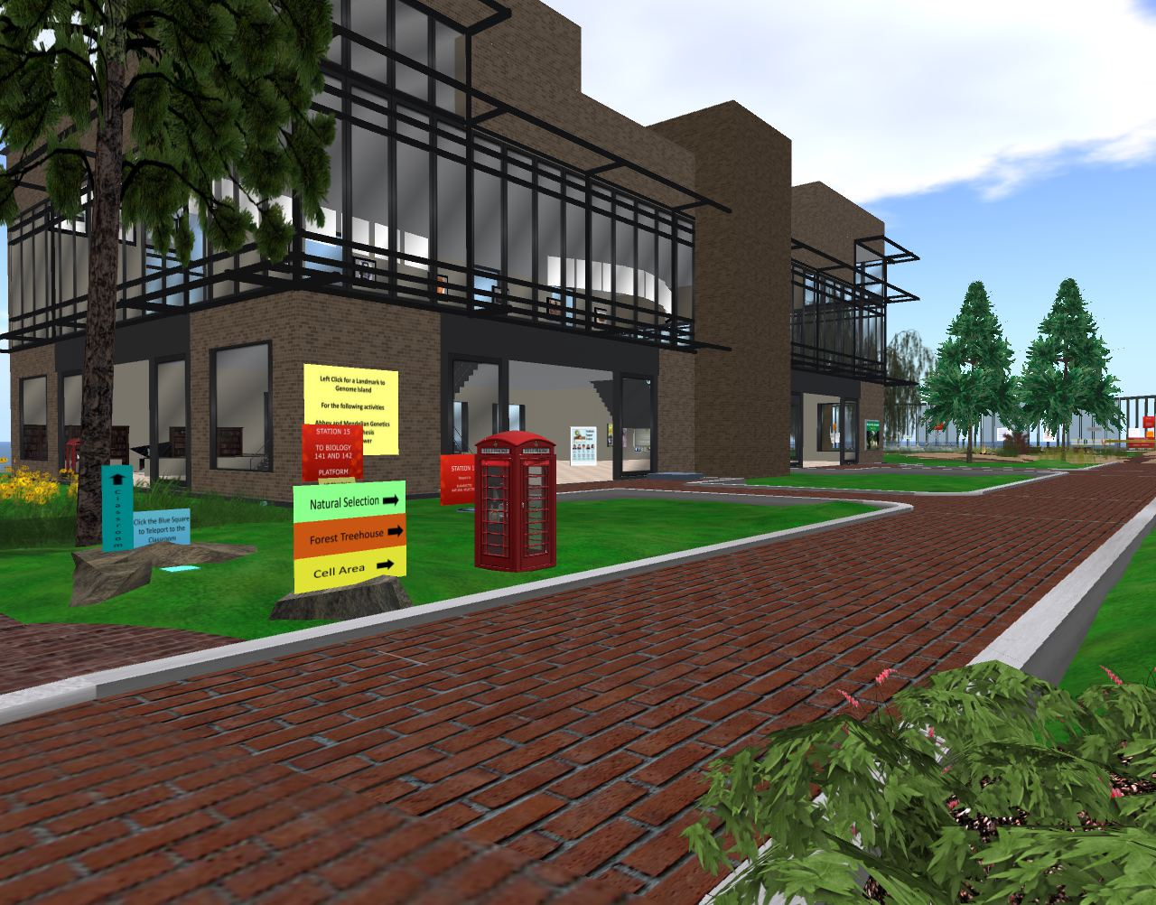

Security

SL is like a large city. At any time there are about 50,000 people logged in. Most of those people are nice and respectful, but like any city, there are people who might bother you. As long as you stay on the NOVA Island, it is unlikely anyone will bother you. Most the avatars you will see at NOVA are other students or professors, so feel free to chat with them. Be aware that on the region nudity as well as abuse or harassment of other students will not be tolerated and anyone doing this will be banned. If someone does bother you, email me (gperrier@nvcc.edu) their avatar name and simply log out of SL and return later. I can block people from coming to the NOVA Island.

How to get to the different locations for the Plant Biodiversity activity

All regions in SL, such as the NOVA region, have a three dimensional grid system. Once you open Firestorm and are on the NOVA region, you will see at the top of your screen a black toolbar with three numbers in the middle of the toolbar.

The coordinates for the landing site are 77, 166, 23. The first number (77) tells you were you are on the east-west axis of the region. When facing the large building, the number will range from 0 far to your left to 256 far to your right. The second number (166) tells you were you are in the north-south direction. Facing the large building, these range from 0 far across the lake behind you to 256 on the other side of the large building. The third number (23) is how high you are. All the plants are on the ground level and so you will not need this number.

In the Activity section of this handout you will see that the east-west and north-south coordinates for each plant are provided in Table 1. You will use the arrow keys on your keyboard to move your avatar to the coordinates provided for each plant. It is easier however, to open the map again and enter the coordinates for the plants in the white boxes next to the word “Location.” You only need change the first two numbers, the last is height and need not be changed.

Plant Biodiversity Activity

Introduction

In this activity you will find 12 different plants located at different locations around NOVA’s region in Second Life (SL) and determine which phylum or class each plant belongs to.

For this activity you will be using your lecture textbook, Principles of Biology by Brooker and others. Chapter 23 in this book covers plant biodiversity. Page 472 in the Brooker textbook shows how the phyla are organized in a tree of life. If you do not have this textbook, just about any biology textbook should work. Look for the chapter on plant diversity and the figure with the plant tree of life. You can also find a general plant tree of life online.

Take a look at the tree of life in your textbook. Note that at the bottom of the tree there are three phyla of algae, these are not plants and so you can ignore them. Algae are aquatic, but all plant phyla are mainly terrestrial, though some species have returned to the water and became aquatic.

The phyla of plants are divided into three broad groups. The simplest group lacks true vascular tissue and only produces spores, not seeds. Vascular tissue in plants is the tissue (Xylem) that brings water from the roots to the leaves and the tissue (Phloem) that takes sugar from the leaves to where sugar is needed in the plant. Without vascular tissue these plants tend to be very short and confined to moist areas where they can get water from diffusion.

All plants produce haploid spores by meiosis. The plant generation that produces spores is called the sporophyte. The spores develop into a gametophyte generation that produces gametes (sperm and eggs). In the simplest plants the gametophyte generation is dominant. The sperm have flagella and swim to the egg and thus these plants are generally found in moist areas. The fertilized egg develops into a small structure, the sporophyte, which produces and disperses spores.

Further up the plant tree of life is found the second broad group. This group has vascular tissues, but does not produce seeds. The dominant generation for these plants is the sporophyte. The spores tend to be produced under the leaves and are dispersed by the wind. The spores that land on moist soil can develop into the small gametophyte which will produce eggs and sperm. Here too, the sperm swim to the egg and thus these plants are generally found in moist areas. The fertilized egg in the gametophyte grows to develop into a sporophyte plant.

The third group of plants has vascular tissue and the gametophyte produces seeds from the fertilized egg. For most of these plants, the sperm are delivered to the female part of the plant from pollen, which can be widely distributed and does not require wet conditions. The majority of plants in this group produce seeds in cones or flowers. The seeds can be dispersed widely and can stay dormant in the soil for a long time.

Filling out table 2

For this activity you will complete Table 2 provided below. Table 2 ask you to 1) correctly identify the phylum or class, 2) correctly located the phylum or class on the plant tree of life figure provided below, and 3) to ensure you have the right plant, to give the location where you found the plant from the list of coordinates found on Table 1.

On the provided tree of life (Figure 1 below) you will see the numbers 1 to 12 corresponding to the phylum or class found at that positon on the figure. Numbers 1 to 10 on this tree of life are for the 10 plant phyla and numbers 11 and 12 are for the 2 classes of flowering plants found on the region.

Also to complete Table 2 you will need to know the location on the region in SL where the plant for each phylum or class is found. Looking on the top black toolbar in the Firestorm program you will see the location of your avatar on the NOVA region given as three coordinate numbers (for example 78, 52, 23). The coordinates for the east-west and north-south location (first two numbers) of the 12 plants are provided in Table 1 below. The third number is for height and is not needed to find the plants on the ground. Table 1 list the 12 coordinates from the lowest first number to the highest and a letter, A to L, is provided for each location coordinate. As your avatar moves around the virtual region you will see these coordinate numbers change. This list of coordinates allows you to find each of the 12 plants.

The quickest way to move your avatar is to teleport to the coordinates. To do this, open the map icon on the bottom toolbar (looks like a map folded into three sections). Near the bottom of the box that opens, you will see the coordinates for your current location in three white boxes next to the word “Location.” Change the coordinates in the first two boxes to the coordinates provided in Table 1 and click on teleport. Once you have teleported you should see the plant biodiversity flag (see image below).
Located at each coordinate location will be the example plant for the phylum or class and next to each of these plants is a green flag with the letters BD-P (for BioDiversity Plants) (see image on the next page). Similar flags, but brown, scattered around the region with the letters BD-A are for an animal biodiversity activity. Have your avatar stand near the flag and you should be within a few meters of flag coordinates. Use Table 1 to determine which letter corresponds to the coordinates of that flag and enter that letter (A to L) in column 4 of Table 2

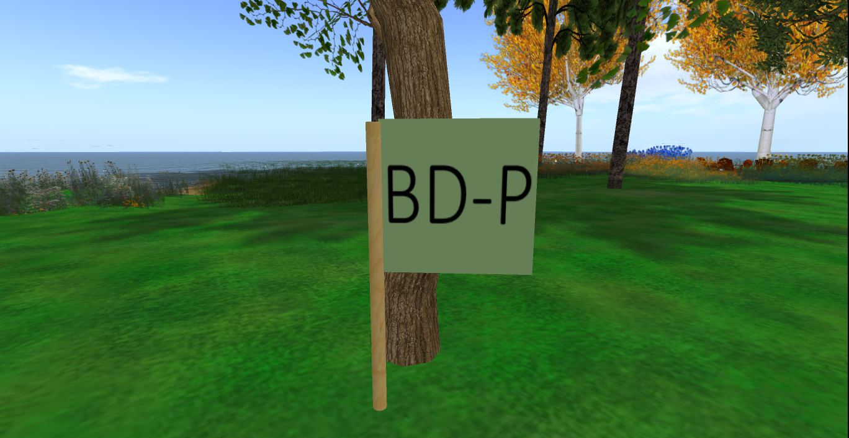

Left clicking on the flag will provide you with a notecard. You will see a blue box appear in the top right of your screen and simply click on accept and the notecard will appear on your screen. If you have problems getting the notecard, right click on the flag and select touch from the menu that appears. Each notecard describes the main characteristics for a specific phylum or class, but it does not tell you which phylum or class the plant is in. Some of the notecards provide an image of the plant. From the information provided in the notecard and from the information in chapter 23 in the Booker textbook, you should be able to identify the phylum or class the plant belongs to.

Once you have completed Table 2 and answered the questions at the end of this handout, copy both pages into a separate Word document and email this document to your professor, either as an attachment or in the body of the email.

Finally, you need to send a photo of your avatar at one of the plant flags to prove you were there. There are three ways to do this. First, you can use your smart phone to take a photo of the computer screen and email this photo to your professor.

Second, you can do a screen capture or print screen and then copy this image into an email or attach it to an email and send the email to your professor.

The third way is you can take a photo of your avatar using the Firestorm program. To do this use the camera icon on the toolbar at the bottom of your SL screen to take a photo. Holding your cursor over this icon you will see the word “snapshot.” Click on the icon and in the window that opens click on “Selection” in the bottom left. Do not save the photo to your inventory (that cost money) but select the email option and email the photo to your professor. You can also select the disk option and save the photo to your computer and then attach it to an email you send to your professor. These emails will have your avatar’s name, so be sure to type your real name in the title of the email so your professor can give you credit for the photo. So use whichever of these three methods works easiest for you.

You are done! I hope you enjoyed exploring the region and learning about the different phyla and classes of plants.

Figure 1. Tree of Life

11 7 8 9
12
6

Flowering
Plants

10

5
Seeds and
Vascular

4

Seedless
Vascular

3

2

1
Terrestrial
Seedless and
Nonvascular

Letter for location | Location coordinates
A | 24 109
B | 38 -195
C | 62 89
D | 105 61
E | 131 19
F | 158 34
G | 166 14
H | 178 220
I | 182 114
J | 186 189
K | 210 12
L | 240 73

Table 1. Locations

Student Name _________________

Avatar Name _________________

Table 2. Tree of life number and location letter for each phyla and class.
Phyla or Class - alphabetically | Common name | Number from  the tree of life | Letter from  Table 1
Anthrocerophyta | Hornworts
Anthophyta | Angiosperms
Byrophyta | Mosses
Coniferophyta | Conifers
Cycadophyta | Cycads
Dicotyledoneae | Class - Eudicots
Ginkophyta | Ginko
Gnetophyta | Gnetophytes
Hepatophyta | Liverworts
Lycophyta | Club moss
Monocotyledoneae | Class - Monocots
Pterophyta | Ferns

Student Name _________________

Avatar Name _________________

Question page

1. What distinguishes the three broad groups of plants?

2. Why must the simplest plants be short and in wet places?

3. In the non-vascular plants, which generation (sporophyte or gametophyte) is dominant?

4. What advantage did vascular tissue provide more advanced plants?

5. What advantage did seeds provide the most advance plants?

6. What is the advantage of pollen over flagellated sperm for carrying the male genetics to the female?

7. In the seed plants, what advantage did flowers provide that cones did not?

8. In the seed plants, which generation (sporophyte or gametophyte) is dominant?

