Handout for the Animal Biodiversity Activity in Second Life
Developed by Dr. Greg Perrier, NOVA

Introduction

NOVA has a region in a virtual world called Second Life (SL). One of the many interactive activities on this region explores the biodiversity of animals. In this activity you will find on the virtual region animals from 10 different phyla as well as animals from the six classes of vertebrates. At each animal, you will get a text notecard that provides you with information on that animal and using that information and your textbook, you should be able to identify the phylum and correctly place this phylum on the animal tree of life.

This handout assumes that you are starting at the Landing Site on the NOVA region in Second Life (see image below). Your professor should have provided you with a separate handout that told you how to download the Firestorm program we use for Second Life, how to get an avatar, how to visit an orientation site, and how to get to the landing site on the NOVA region.

Whenever you wish to exit Second Life, left click on the white X in the red box on the
top right of your screen. When you return to Second Life, your avatar will appear at the same location it was when you logged off.

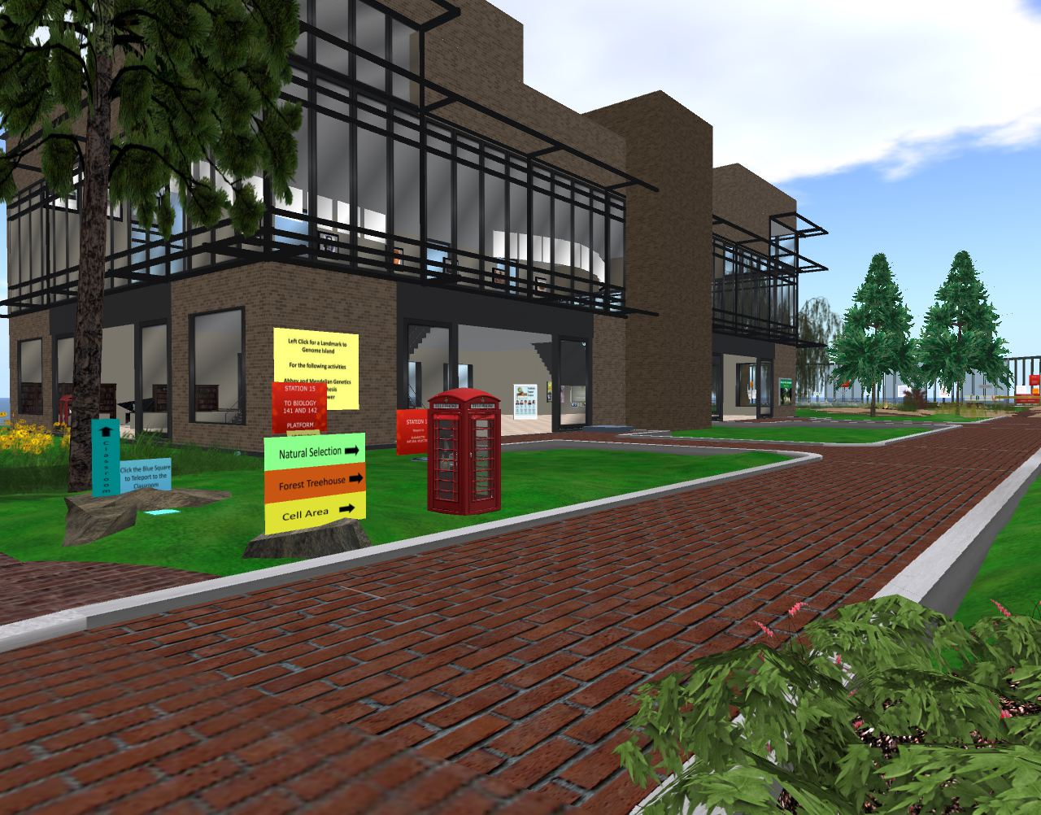

Security

SL is like a large city. At any time there are about 50,000 people logged in. Most of those people are nice and respectful, but like any city, there are people who might bother you. As long as you stay on the NOVA Island, it is unlikely anyone will bother you. Most the avatars you will see at NOVA are other students or professors, so feel free to chat with them. Be aware that on the region nudity as well as abuse or harassment of other students will not be tolerated and anyone doing this will be banned. If someone does bother you, email me (gperrier@nvcc.edu) their avatar name and simply log out of SL and return later. I can block people from coming to the NOVA Island.

How to get to the different locations for the Animal Biodiversity activity

All regions in SL, such as the NOVA region, have a three dimensional grid system. Once you open Firestorm and are on the NOVA region, you will see at the top of your screen a black toolbar with three numbers in parentheses in the middle of the toolbar. The coordinates for the landing site are 77, 166, 23.

The first number (77) tells you were you are on the east-west axis of the region. When facing the large building, the number will range from 0, far to your left, to 256, far to your right. The second number (166) tells you were you are in the north-south direction. Facing the large building, these range from 0, far across the lake behind you, to 256 on the other side of the large building. The third number (23) is how high you are. All the animals are on the ground level or under the water and so you will not need this number.

Left click on the map icon (looks like a map folded in three sections) on the bottom toolbar. When this opens, you will see a map of the region. Note that along the sides are E, W, N, and S for east, west, north, and south. You can also see where your avatar is located on the map; if any other avatars are there, they will show as green dots on the map.

In the Activity section of this handout you will see that the east-west and north-south coordinates for each animal are provided in Table 1. You can use the arrow keys on your keyboard to move your avatar to the coordinates provided for each animal. It is easier however, to open the map again and enter the coordinates for the animals in the white boxes next to the word “Location.” You only need change the first two numbers, the last is height and need not be changed.

Activity 17: Animal Biodiversity

Introduction

The purpose of this activity is to help you better understand the diversity within the animal kingdom. There are about 30 phyla in the animal kingdom. This activity includes only 10 of these phyla. Six classes within the phylum Chordata are also covered in this activity. The 10 phyla and 6 Chordata classes result in a total of 16 animals you must find and correctly place on the tree of life for the animal kingdom.

To complete this activity you simply fill in Table 2 and answer the questions listed at the end of this handout. You email the completed Table 2 and the answered questions to your professor. Table 2 ask you to place the animal in the correct phyla or class, to provide the location where you found each animal on the region as well as to correctly place the animal on the animal kingdom tree of life.

For this activity you will be using your lecture textbook, Principles of Biology by Brooker. Chapter 25 in this book covers animal biodiversity. Page 511 in the Brooker textbook shows how different phyla are organized in a tree of life.

Take a look at the tree of life in your textbook. Note that at the bottom of the tree is the one phylum that is asymmetric and lacks true tissues. Moving up, you get into animals that have true tissues. The lowest of these has a bilateral symmetry.

Moving up further the tree of life branches into two broad groups of animals, the Protostomia and Deuterostomia, which differ in their embryological development. These embryological differences are discussed on page 513 in the Booker textbook.

The Protostomia are further divided into two groups, the Lophotrochozoa and the Ecdysozoa. These are discussed on page 516 in the Booker textbook. The Lophotrochozoa share a common larval form, though the adult forms are very different. The Ecdysozoa have an exoskeleton which they must shed periodically when they grow larger. The tree of life in the Booker textbook shows 6 phyla in the Lophotrochozoa. Only 4 of these will be found on NOVA’s region in SL. When developing your tree of life information, place the phyla in the order for the Lophotrochozoa and Ecdysozoa as they are in the Booker texbook.

Information of the two phyla in the Deuterostomia can be found in the Booker textbook on page 537. On your tree of life information, place these two phyla in the same order as in the textbook.

The tree of life below shows six of the seven vertebrate classes. The jawless vertebrates are not included. A tree of life for these 6 classes can be found in the Booker textbook on page 545.

Several pages below you will find a tree of life diagram with numbers 1 to 16 for the different phyla and classes you need to identify. Table 1 is on the page directly below the tree of life. This table gives you the coordinates for the location for each of the 16 animals you need to identify. A letter (A to P) has been assigned to each of the coordinates.

Filling out table 2

To complete Table 2 provided below, you will need to find on the region each of the 16 animals for this activity. Table 1 provides the coordinates for the location for each of these animals so that you can find them.

Looking on the top black toolbar in the Firestorm program you will see the location of your avatar on the NOVA region given as three coordinate numbers (for example 78, 52, 23). The first number is the coordinate for the east-west direction. The second number is the coordinate for the north-south direction. The third number is for height and is not needed to find the animals on the ground. Move your avatar around and you will see these coordinates change. By moving you avatar to the coordinates provided in Table 1 you can find each of the 16 animals.

The quickest way to move your avatar is to teleport to the coordinates. To do this, open the map icon on the bottom toolbar (looks like a map folded into three sections). Near the bottom of the box that opens, you will see the coordinates for your current location in three white boxes next to the word “Location.” Change the coordinates in the first two boxes to the coordinates provided in Table 1 and click on teleport. Once you have teleported you should see the animal flag (see image below).

At each coordinate location will be the example animal for the phylum or class and next to each of these animals is a brown flag with the letters BD-A (for BioDiversity Animals) (see image below). Four of the small invertebrate animals only appear once you have left clicked on the flag. Similar flags, but green, are scattered around the region with the letters BD-P. They are for a plant biodiversity activity.

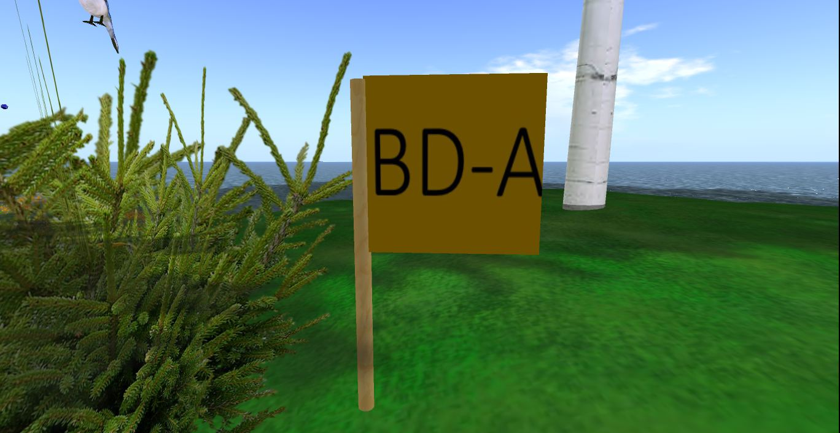

Left clicking on the flag will provide you with a text notecard. You will see a blue box appear in the top right of your screen. You simply click on “Accept” and the text notecard will appear on your screen. If you have problems getting the notecard, right click on the flag and select “touch” from the menu that appears. The notecard for each phylum or class will give you the information you need to correctly identify the phylum of the animal at that flag.

To see the animal better you can open the “camera controls” which allow you to move your view right or left, up or down, and to rotate the view. To do this, click on the icon on the bottom toolbar that looks like an eye, a dot inside of an eye shaped oval. This will open a box on your screen. Inside this box are two boxes, the one on the right moves your view up and down or right and left. The box on the left rotates your view.

To zoom in on an animal, hold down the ALT key. You should see your curser looking like a magnifying glass. Put your curser over the animal and left click. You can now use your mouse wheel to zoon in and out.

To complete this activity, you are to fill in the last two columns in Table 2. The first two columns on Table 2 give you the name of the phylum or class and the common name for the animal. In the third column, enter the number from the Tree of Life associated with the phylum or class listed in the third column. In the fourth column provide the letter from Table 1 associated with the location of the animal from that phylum or class. The list of phyla and classes in Table 2 is alphabetical.

Next on the last page of this handout you will find a list of questions about animal biodiversity that you should be able to complete once you have filled in table 2.

Once you have completed Table 2 and answered the questions at the end of this handout, copy both pages into a separate Word document and email this document to your professor, either as an attachment or in the body of the email.

Finally, you need to send a photo of your avatar at one of the animal flags to prove you were there. There are three ways to do this. First, you can use your smart phone to take a photo of the computer screen and email this photo to your professor.

Second, you can do a screen capture or print screen and then copy this image into an email or attach it to an email and send the email to your professor.

The third way is you can take a photo of your avatar using the Firestorm program. To do this use the camera icon on the toolbar at the bottom of your SL screen to take a photo. Holding your cursor over this icon you will see the word “snapshot.” Click on the icon and in the window that opens click on “Selection” in the bottom left. Do not save the photo to your inventory (that cost money) but select the email option and email the photo to your professor. You can also select the disk option and save the photo to your computer and then attach it to an email you send to your professor. These emails will have your avatar’s name, so be sure to type your real name in the title of the email so your professor can give you credit for the photo. So use whichever of these three methods works easiest for you.

You are done! I hope you enjoyed exploring the region and learning about the different phyla and classes of animals.

TREE OF LIFE FOR ANIMAL BIODIVERSITY

3 4 5 6 7 8 16 15

14

9 10
13

Ecdysozoa
Lophotrochozoa

12

11

Deuterostomia
Protostomia

2
Bilateral
Symmetry

mmetry
Radial
Symmetry

1

Asymmetric

Table 1. Animal Locations
Letter | Coordinates
A | 33 - 136
B | 48 – 197
C | 53 – 91
D | 63 – 229
E | 101 – 78
F | 104 – 106
G | 113 – 132
H | 120 – 18
I | 129 – 121
J | 137 – 124
K | 142 – 130
L | 162 – 82
M | 165 – 125
N | 168 – 44
O | 169 – 127
P | 200 – 55

Student name ________________
Avatar name ________________

Table 2. Copy the completed table and email as an attachment to your professor.

Phylum or Class | Common Name | Number on  Tree of Life | Letter for  Coordinates
Amphibia | Amphibians
Annalida | Segmented worms
Arthopoda | Insects / Crustaceans
Aves | Birds
Chondrichthyes | Cartilageous fish
Chordata | Vertebrates
Cnidaria | Jellyfish
Echinodermata | Sea star
Mammalia | Mammals
Mollusca | Mollusk
Nematoda | Round worms
Osteichthyes | Boney fish
Platyhelminthe | Flatworms
Porifera | Sponges
Reptilia | Reptiles
Rotifera | Rotifers

Student name ________________
Question page Avatar name ________________

1. Contrast the symmetry of the two simplest phyla of animals on the provided tree of life?

2. Contrast the embryological development of the Protostomia and the Deuterostomia.

3. Why are the animals in the Lophotrochozoa grouped together, even though the adult forms are very different?

4. What is the common characteristic of the two Ecdysozoa phyla?

5. What is the common characteristic of the Chordata phylum?

6. Contrast the two fish vertebrate classes.

7. What adaptations did reptiles have to make to become totally independent of water?

8. What are the four distinguishing characteristics of mammals?

